Coordination Mechanism for Cooperation in Forestry between China and the CEE Countries

2nd High Level Meeting

14-15 May 2018, Palace “Serbia”, Belgrade, Serbia

Practical Information (updated)

Bellow you will find information on the meeting, venue, accommodation and other practical information.

Registration
Participants are kindly invited to register by 30th April 2018. .

For any technical issue connected to 2nd HLM and side events participants are invited to contact:

Ms. Nina Baloh
Mr. Predrag

Meeting dates and timing
The 2nd High Level Meeting will be held on 14 May 2018 at the Palace “Serbia”, Room “Belgrade” Belgrade, Serbia.
Registration of participants will start at 8:00.
The LG meeting is scheduled to start at 9:00 OM Monday 14 May 2018 and will last until 11:00 in Palace “Serbia”, Room “Makedonija”
The HLM is scheduled to start at 12:00 on Monday 14 May 2018 and will last until 17:00 in Palace “Serbia”, Room “Beograd”.
Side event – Scientific Cooperation Workshop will be held on 14th May 2018 at the Club of the Members of the Parliament (Address: Tolstojeva 2). Registration will start at 8:00.
On Tuesday 15 May 2016 all participants are invited for opening of 85. International Agricultural Fair in Novi Sad. Transportation by bus in front of the hotel Hyatt will start at 9:00. Return from Novi Sad (approx. 100 km from Belgrade) planned for 16:00 hours.
Participants of all events are kindly invited to a dinner that will take place at 19:00 on Monday 14 May 2016 at the Club of the Members of the Parliament (Address: Tolstojeva 2) .

Venue

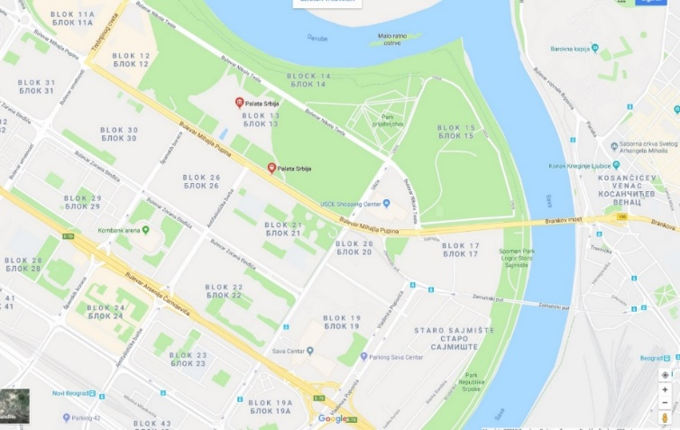
The 2nd HLM will take place in the Palace “Serbia”, Boulevard Mihajla Pupina 2, Belgrade. Registration desk and information point will be located near the entrance to the conference hall.

https://foursquare.com/v/palata-srbije--siv-1/4d5fa6649f67f04d450a6ffb

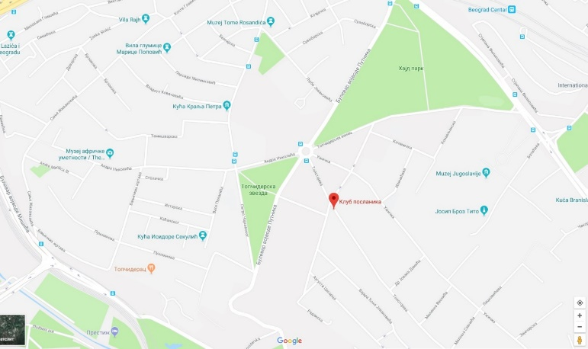
Scientific Cooperation Workshop will take place at the Club of the Members of the Parliament, Tolstojeva 2, Belgrade. Registration desk and information point will be located near the entrance to the conference hall.
https://foursquare.com/v/klub-narodnih-poslanika/4eb24cb08b815ab741c71b8a

Language & Documentation
The meeting will be held in English and interpreted into Chinese and Serbian. The background documents for the meeting will be in English and delivered in due time.

Meals
There will be coffee breaks and lunch during the 2nd HL Meeting on Monday.

There will be coffee breaks and lunch during the Scientific Cooperation Workshop on Monday.

Arrival details and public transport
To travel to Belgrade, you can take a flight to Belgrade International Airport.
The major airport is the Nikola Tesla airport, located 14 km west of Belgrade.
Travel from the airport to Belgrade Participants can take shuttle bus (about exact time and place of hotel busses participants will be informed in due time) or taxi (taxi desk is located on the exit of the airport, and the price should not be higher than 1700-2000 RSD, approx. 15-18 EUR)
Accommodation
Participants are kindly requested to make their own accommodation arrangements by using agency in charge of accommodation arrangements. Rooms for all of the participants are reserved in the Hotel Hyatt.
In that sense participants are advised to contact Ms. Nina Ilić (Sky Multicom - [office@skymulticom.com], tel: +381 11 3139886; +381 64 1860625)

You can contact Ms. Nina Ilić [office@skymulticom.com] in order to arrange your reservations with the following reference:
2nd High Level Meeting Coordination Mechanism for Cooperation in Forestry between China and the CEE Countries

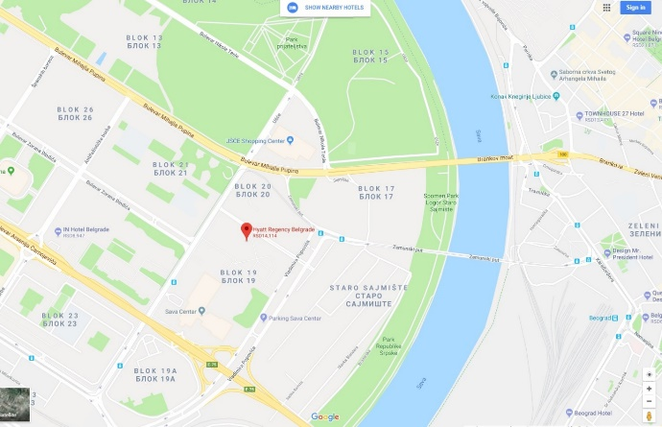
Hotel Hayatt****
Address: Milentija Popovića 5, New Belgrade
Phone: +381 11 3011234
Web: https://belgrade.regency.hyatt.com/en/hotel/home.html
Price: Single room: 110 EUR/room/night (including breakfast)
Special offer is valid till 30 April 2018. After this deadline hotel rooms and special rates cannot be guaranteed.

ACCOMODATION support
Accommodation support for this meeting is available for heads of delegation plus one person, except for Chinese delegation who will be fully covered with accommodation by the organizer.

Visa Information
Participants are responsible for checking visa requirements and making their own visa arrangements before departure, including visa for transit or stopover. For further information regarding to visa requirements please visit the website of the Ministry of Foreign Affairs of the Republic of Serbia: http://www.mfa.gov.rs/en/consular-affairs/entry-serbia/visa-regime. In general, visa for Serbia is not needed for European countries.

Currency
The official currency in Serbia is the Dinar (RSD). Exchange rate for 1 EUR is around 118 RSD. Foreign currency can be changed in banks or exchange offices. Credit and debit cards (Visa, Visa Electron, Eurocard/Mastercard, Maestro, American Express, Diners Club) are widely accepted.

General Information
For general information on the city and the country, please visit the webpages: http://www.tob.rs

FURTHER INFORMATION and Contact Persons
For further information regarding to the 2nd HLM or Scientific Cooperation Workshop, do not hesitate to contact us:

Ms. Nina Baloh  Undersecretary  Forestry, Hunting and Fisheries Directorate  Ministry of Agriculture, Forestry and Food of the Republic of Slovenia  Coordinating Section for the forestry cooperation between Central and Eastern European Countries and China |  | Mr. Predrag Jović  Senior Adviser  Directorate of Forests  Ministry of Agriculture, Forestry and Water Management of the Republic of Serbia
Tel.: +386 (0)1 478 91 15  e-mail: nina.baloh@gov.si |  | Tel.: +381 (0)11 3117566, 3130134  Mobile phone: +381 65 3593525  e-mail: predrag.jovic@minpolj.gov.rs

2nd High Level Meeting of the Coordination Mechanism
for Cooperation in Forestry between China and the CEE Countries
(REGFORM for 2nd HLM)

Belgrade, 14-15 May 2018

Delegates are kindly requested to fill out the registration form in capital letters and email to predrag.jovic@minpolj.gov.rs

The registration deadline is 30 April 2018

Title: | ___________________________________
First name: | ___________________________________
Last name: | ___________________________________
Position/function: | ___________________________________
Institution: | ___________________________________
Institution address (street, street number, postal code, city/town, country): |  | ___________________________________
___________________________________________________________________
Phone or mobile number: |  |  | e-mail:
_________________________ |  |  | ______________________________
TRAVEL DETAILS:
Arrival date: ________________ |  |  | Departure date: ___________________
Arrival time: ________________ |  |  | Departure time: ___________________
Mean of transport: ____________ |  |  | Mean of transport: _________________
Flight no: __________________ |  |  | Flight no: _______________________
OTHER INFORMATION:
Hotel:_____________________
Special dietary requirements: _________________________________________________
Date: _____________________ |  |  | Signature: _______________________

2nd High Level Meeting of the Coordination Mechanism
for Cooperation in Forestry between China and the CEE Countries
(REGFORM for SEMINAR ON China- CEECs Forest Science Cooperation)

Belgrade, 14-15 May 2018

Delegates are kindly requested to fill out the registration form in capital letters and email to predrag.jovic@minpolj.gov.rs

The registration deadline is 30 April 2018

Title: | ___________________________________
First name: | ___________________________________
Last name: | ___________________________________
Position/function: | ___________________________________
Institution: | ___________________________________
Institution address (street, street number, postal code, city/town, country): |  | ___________________________________
___________________________________________________________________
Phone or mobile number: |  |  | e-mail:
_________________________ |  |  | ______________________________
TRAVEL DETAILS:
Arrival date: ________________ |  |  | Departure date: ___________________
Arrival time: ________________ |  |  | Departure time: ___________________
Mean of transport: ____________ |  |  | Mean of transport: _________________
Flight no: __________________ |  |  | Flight no: _______________________
OTHER INFORMATION:
Hotel:_____________________
Special dietary requirements: _________________________________________________
Date: _____________________ |  |  | Signature: _______________________

