The International Conference on China-CEECs Forestry Research and Education Cooperation

Introduction - 1 -
Opening ceremony - 1 -
Keynote Speeches - 4 -
Thematic Presentations and Discussion - 6 -
Closing Ceremony - 10 -

Introduction
Nearly 180 representatives from government sectors, forestry research institutes, universities and enterprises from China and Central and Eastern Europe countries (CEEC or “16+1”) gathered in Beijing between 30th and 31st October 2017 to participate in the International Conference on China-CEECs Forestry Research and Education Cooperation. The purposes of the Conference were to implement the “Action Plan for the Cooperation within the Framework of the Coordination Mechanism for the Cooperation in Forestry between China and CEE Countries” adopted at the First China-CEEC High-level Meeting on Cooperation in Forestry held in May 2016, to reinforce communications and exchanges in forestry sector between China and CEEC, to enhance the consensus of relevant countries in forestry collaboration, to establish the foundation of “16+1” forestry research and education cooperation, and to discuss about the concrete and potential directions and channels of cooperation.
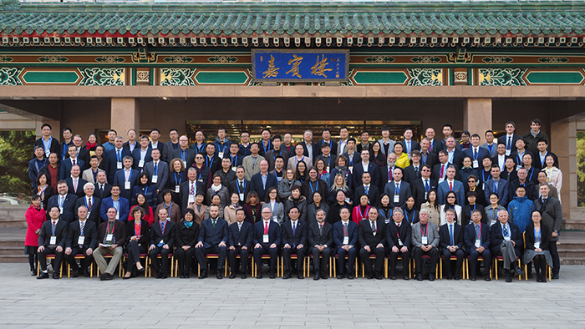

Opening ceremony
Mr. Liu Dongsheng, Vice Minister of the State Forestry Administration of China (SFA), Mr. Janez Zafran, Director General of Forestry, Hunting and Fishery Directorate of the Ministry of Agriculture, Forestry and Food of Slovenia and the Director of the Executive Coordinating Body for China-CEEC Forestry Cooperation, and Mr. Andrzej Antonio Konieczny, Vice Minister of the Ministry of Environment of the Republic of Poland attended the opening ceremony and delivered opening remarks respectively. Mr. Wu Zhimin, Director General of the Department of International Cooperation of SFA hosted the opening ceremony.

The remarks of the representative from the SFA
Mr. Liu Dongsheng mentioned that there was huge potential between China and CEECs in forestry cooperation. The SFA would like to make concerted efforts with CEECs to consolidate and open up bilateral cooperation channels and strongly support the development of the Coordination Mechanism of Forestry Cooperation between China and CEECs. Mr. Liu made three proposals on further deepening China-CEECs forestry research and education cooperation: First, strengthen research cooperation and promote sharing of achievements. He encouraged academic leaders in forestry from relevant countries to initiate theoretical and academic seminars, jointly implement international research cooperation projects and build the platform for research achievements sharing. Second, promote personnel exchanges, cultivate professionals, enhance transformation of achievements and fostering of applied talents, and carry out capacity building. Third, encourage forestry education cooperation, explore and set up joint training mechanism, fully tap the potential of advantageous disciplines of relevant countries and broaden the space for personnel training between China and CEECs.

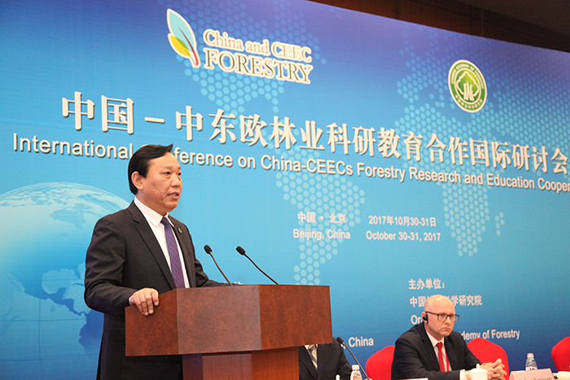
Mr. Liu Dongsheng, Vice Minister of the State Forestry Administration of China (SFA) gave his opening remarks

The remarks of the representative from the Executive Coordinating Body for China-CEEC Forestry Cooperation
Mr. Janez Zafran said that “16+1” cooperation was designed to construct a new cooperation model featured openness, inclusiveness and win-win solution to improve the practical cooperation between China and CEECs in different fields. Slovenia would endeavor to enhance the consensus and promote cooperation among involved countries in forestry through facilitating information exchanges, policy dialogue and the establishment of exchange platform.

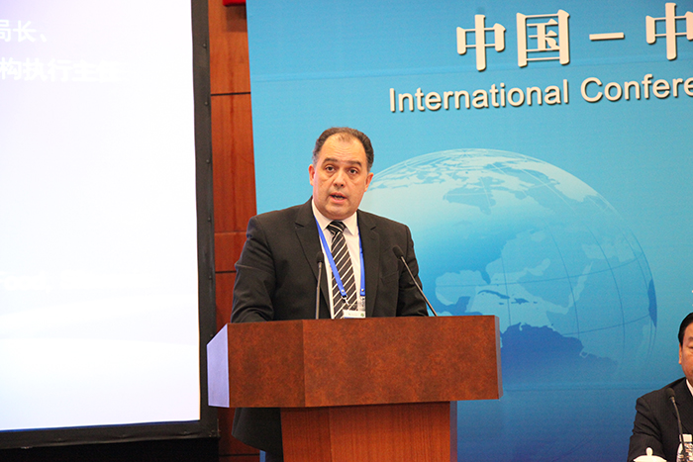
Mr. Janez Zafran, Director General of Forestry, Hunting and Fishery Directorate of the Ministry of Agriculture, Forestry and Food of Slovenia and the Director of the Executive Coordinating Body for China-CEECs Forestry Cooperation delivered his opening speech.

The remarks of the representative from CEECs
Mr. Andrzej Antonio Konieczny said in his opening remarks that forestry development of Poland is among the top leading countries in Europe. In 2014, the Polish Ministry of Environment signed an MOU with the SFA of China for boosting the future cooperation with China in sustainable forest management, forest products trade, combating climate change and research and education.
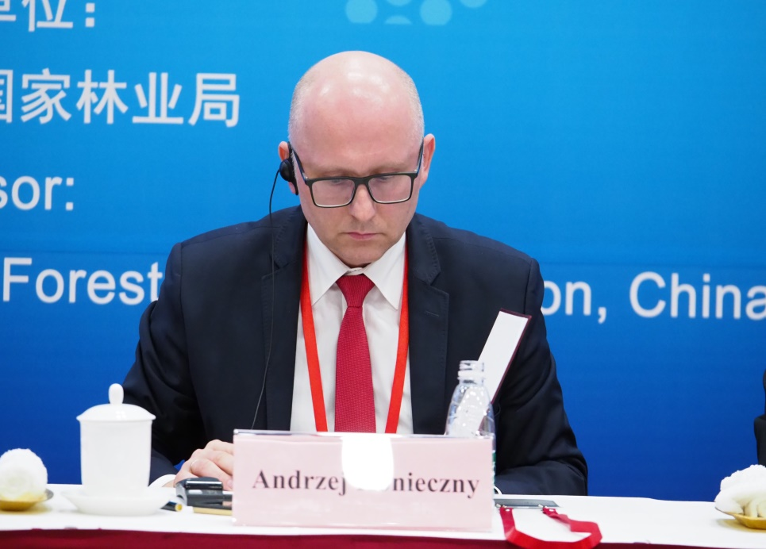
Mr. Andrzej Antonio Konieczny, Vice Minister of the Ministry of Environment of the Republic of Poland addressed the conference.

Keynote Speeches
Mr. Du Jishan, Deputy Director General of the Department of Science and Technology of the SFA, Professor Miha Humar, Dean of the College of Biotechnology of the University of Ljubljana and Mr. Kong Tianping, Research Fellow of the Institute of Eastern Europe Studies, Chinese Academy of Social Sciences (CASS) made keynote speeches on “Overview of China’s Forestry Research”, “Overview of Forestry Research in CEECs” and “Reflections on the Cooperation between China and CEECs” respectively.

Speech by the representative from the SFA
Mr. Du Jishan elaborate the general situation of China’s forestry technologies, forest genetics and breeding, silviculture and management, ecological improvement and conservation, industrial transformation and upgrading, Science and Technology (S&T) achievements dissemination, international S&T cooperation, and S&T development plan. He presented the current situation of S&T development of China’s forestry with detailed data and pictures and introduced forestry cooperation projects launched between China and CEECs, such as the projects in Albania, Latvia and Czech Republic that yielded fruitful results. In the meantime, he also expressed the willingness to further the cooperation with CEECs in forestry S&T.
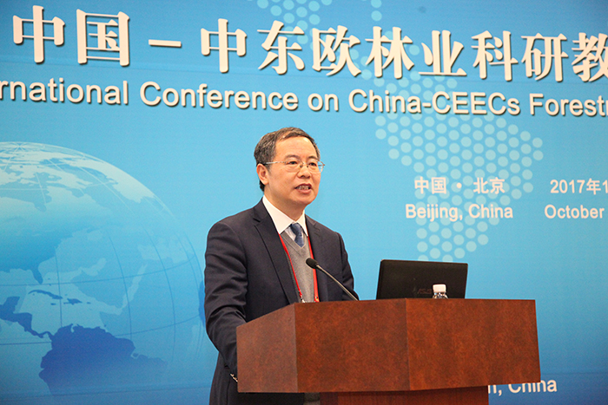
Mr. Du Jishan, Deputy Director General of the Department of Science and Technology of the SFA made his speech.

Speech by the scentific researcher from CEECs
Prof. Miha Humar comprehensively introduced the present situation of forestry scientific research, circular economy, and timber industry chain in CEECs, as well as the opportunities and challenges of CEECs forestry development. Professor Miha Humar is also the member of Slovenia Commerce Committee, so he expressed the strong desire of Slovenia Commerce Committee to strengthen the cooperation with China.
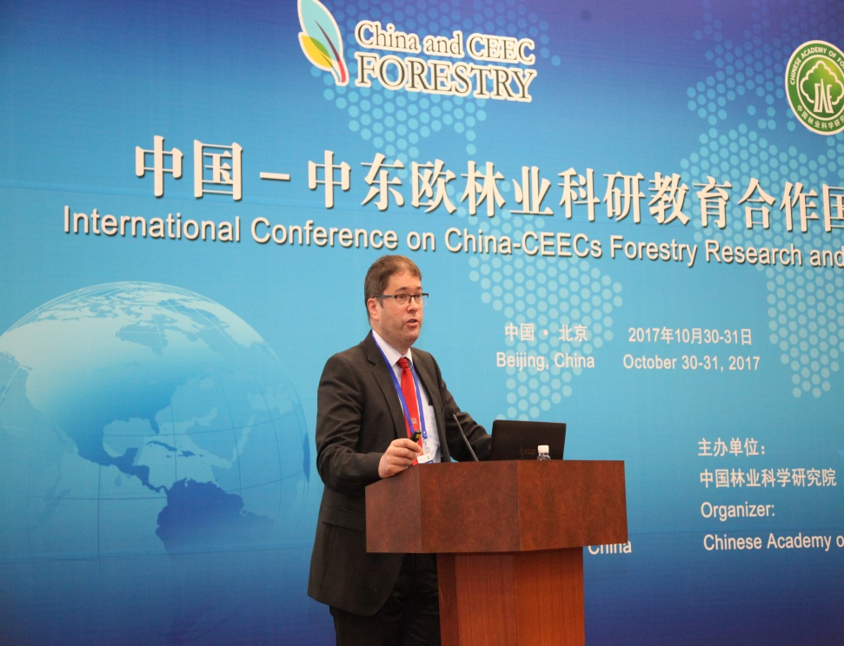
Prof. Miha Humar, Dean of the College of Biotechnology of the University of Ljubljana delivered his keynote speech.

Speech by the representative from the CASS
Mr. Kong Tianping introduced the origin, characteristics, progress and prospects of “16+1” cooperation and the relation between “the Belt and Road Initiative (BRI)” and “16+1” cooperation. He explained the necessity of “16+1” cooperation from the perspectives of history and policy to illustrate that “16+1” cooperation boosts the balanced development of Sino-European relations, and proposed visions and suggestions for future cooperation.
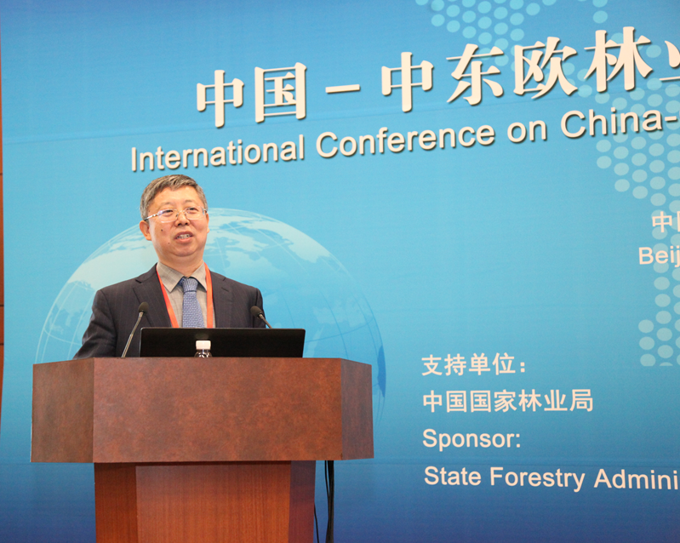
Mr. Kong Tianping, Research Fellow of the Institute of Eastern Europe Studies, Chinese Academy of Social Sciences (CASS) delivered his keynote speech at the conference.

Thematic Presentations and Discussion
Exchanges and discussions were organized on the following five themes: silviculture, forest ecology, environment and protection, monitoring and assessment of forests, biological economy of forestry and forestry education and training. Eleven representatives from China and 16 representatives from CEECs introduced their main research directions, progresses, suggestions and opinions on forestry cooperation between China and CEECs respectively (see the table below for subjects, speakers and contact information). Participants discussed the ideas, ways and approaches of cooperation under each respective theme, which could be summarized as follows:

- Silviculture
In spite of the differences in forest management and cultivation technologies, the participants expressed the strong will of cooperation on silviculture, especially in cultivation of mixed forests and studying the position and roles of forests in addressing climate change. Specific seminars were expected to be organized to share the progresses and achievements of the researches in relevant fields..

- Forest Ecology, Environment and Protection
Participants called for cooperative researches in forest ecology and radial growth of trees and suggested to push forward the interdisciplinary cooperation and exchanges in relevant fields on current basis. They agreed that this conference had promoted the academic exchanges in forest ecology, environment and protection, and hoped that the conference can contribute to the establishment of the platform providing opportunities for interdisciplinary cooperation among relevant countries.

- The monitoring and assessment of forests
Participants exchanged the state of the art technologies, data requirements, and the environment monitoring and assessment for forest resources monitoring and assessment. They approved the significance of sharing the results of data acquisition and analysis and expected to establish expert network, enhance exchanges of young scholars, explore the potential of further cooperation, organize academic seminars and carry out pilot projects of data synergy through “16+1” cooperation platform.

- Biological Economy of Forestry
The participants expressed the hope that in-depth discussions could be carried out with the help of “16+1” platform to share the technologies and experiences of biological economy of forestry among involved countries, and discussed with the industries on the cooperation areas of common interests and their specific collaboration directions, such as the development of new technologies and jointly advance the development of biological economy of forestry and circular economy.

- Forestry Education and Training
The participants wished to further reinforce bilateral exchanges, such as the exchanges of teachers and students and joint training of postgraduates and doctoral candidates, and to explore the cooperation mechanism for promoting education exchanges.

Theme 1: Silviculture
Host: Lei Xiangdong (China) and Jurgis Jansons (Latvia)
Country | Host | Theme of Report | Email
China | Lei Xiangdong | Forest Management in China: from quantity to quality | xdlei@ifrit.ac.cn
China | Jia Liming | Research status of silviculture in China and the cooperation prospect with CEECs | jlm@bjfu.edu.cn
Latvia | Jurgis Jansons | Silviculture- Research progress, potential content and channels of future cooperation | Jurgis.jansons@silava.lv
Slovenia | Hojka Kraigher | Why forest genetic resources matter? | Hojka.kraigher@gozdis.si
Lithuania | Marius Aleinikovas | Carbon accounting in harvested wood products: experience of Lithuania | Marius.aleinikovas@mi.lt
Theme 2: Forest Ecology, Environment and Protection
Host: Wang Xiaoyi, Monika Figaj
China | Wang Xiaoyi | Recent progress of forest ecology and protection in China and cooperative prospects | xywang@caf.ac.cn
China | Wang Xiaochun | Research on impacts of climate change on the growth of major tree species in China and possible cooperative research | wangx@nefu.edu.cn
Poland | Andrzej Antoni Konieczny | Research progress, potential areas, channels and patterns of future cooperation | Andrzej.konieczny@mos.gov.pl
Slovenia | Jozica Gricar | Monitoring radial growth and tree anatomy in relation to climate change | Jozica.gricar@gozdis.si
Croatia | Boris Hrasovec | New challenges in Croatian forest protection practices under the pressure of growing number of alien invasive species | hrasovec@sumfak.hr
Theme 3: Monitoring and Assessment of Forests
Host: Pangyong (China) and Robert Marusak (Czech)
China | Pang Yong | The application of remote sensing technology in forest resources monitoring and assessment of China | pangy@ifrit.ac.cn
China | Wang Xuejun | The application of remote sensing technology in the monitoring of forest resources | Wangxuejun320@126.com
Czech Republic | Robert Marusak | Monitoring and assessment of forests | marusak@fld.czu.cz
Slovenia | Primoz Simoncic David Hladnik | The monitoring of forest eco-system | Primoz.simoncic@gozdis.si
Theme 4: Biological Economy of Forestry
Host: Xu Junming (China) and Nike Krajnc (Slovenia)
China | Xu Junming | Report on recyclable resources utilization – the progress in the studies of advanced liquid fuel | finechemistry@163.com
China | Wang Fei | The development and future of biomass energy of forestry in China | hgwf@njfu.edu.cn
Slovenia | Nike Krajnc | Timber utilization and its value chain | Nike.krajnc@gozdis.si
Poland | Piotr Maria Paschalis-Jakubowicz | Forestry Innovation: from innovation to the adoption of development path | Piotr.Paschalis@wl.sggw.pl
Slovakia | Stefan Bohacek | The second generation of bioethanol – advanced biomass energy | bohacek@vupc.sk
Them 5: Forestry Education and Training
Host: Lin Yu (China) and Ioan-Vasile Abrudan (Romania)
China | Lin Yu | Internationalization of forestry higher education – cooperation and win-win situation | duke_lin@163.com
China | Lin Qun | Postgraduate Education in Chinese Academy of Forestry based on scientific research | linqun@caf.ac.cn
China | Lei Xue | The introduction of China’s forestry on-the-job training | Leixue_1022@163.com
Romania | Ioan-Vasile Abrudan | Forestry higher education in Romania: current situation and challenges | abrudan@unitbv.ro
Slovenia | Primoz Oven | Forestry Education and Training in Slovenia | Primoz.oven@bf.uni-lj.si

Closing Ceremony
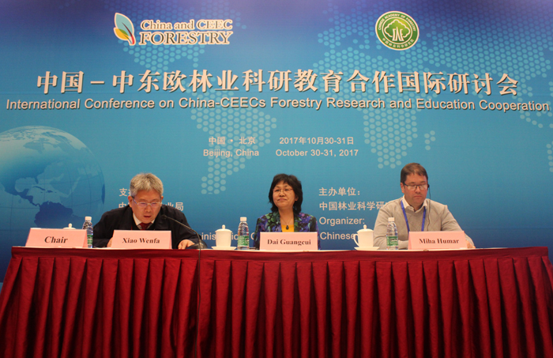
Xiao Wenfa (on the left) hosted the closing ceremony and summarized the Conference. Dr. Dai Guangcui(in the middle) and Prof. Miha Humar (on the right) gave their closing remarks.

Following two days’ heated and efficient discussions, which covered all scheduled topics, the International Conference of China-CEECs Forestry Research and Education Cooperation held by the SFA and the Chinese Academy of Forestry (CAF) concluded in the afternoon of 31th, October, 2017. Dr. Dai Guangcui, Deputy Director General of the Department of International Cooperation of the SFA, and Prof. Miha Humar, Dean of the College of Biotechnology of the University of Ljubljana delivered remarks at the closing ceremony. Dr. Xiao Wenfa, Vice President of the CAF hosted the ceremony and wrapped up the conference.
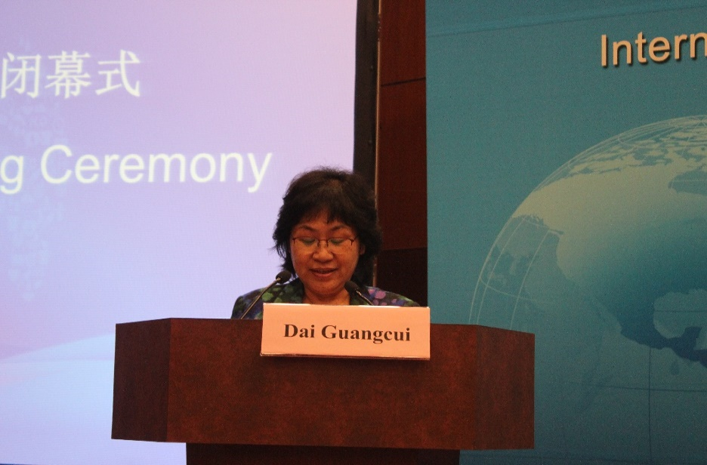
Dr. Dai Guangcui, Deputy Director General of the Department of International Cooperation of the SFA delivered her closing remarks.

Closing Remarks
CEECs are endowed with rich forest resources and equipped with abundant management knowledge. They have a long history of forests utilization and their forest cultures have distinctive characteristics. Both China and CEECs attach great importance to forestry development and share common interests and goals in strengthening forest management, developing multi-functional uses of forests, deepening scientific innovation and education development and enhancing industrial, business and trade cooperation in forestry. Participants from 17 countries gathered together for exchanges, discussions and advices with common interests and goals, which have laid a solid foundation for promoting the forestry cooperation among the 17 countries.

To further advance China-CEECs forestry cooperation, Dr. Dai suggested: 1. Take full advantage of the Coordination Mechanism for Forestry Cooperation between China and CEECs to strengthen communications and collaboration. Give full play to coordinators and the Executive Coordinative Mechanism to promote information exchanges, activities coordination and pragmatic cooperation. Second, make endeavors in the development and maintenance of China-CEECs forestry website for information sharing, timely update information on the website of both Chinese and English versions and make good use of the information resources. Third, push forward the economic and trade cooperation based on strengthened research and education cooperation.
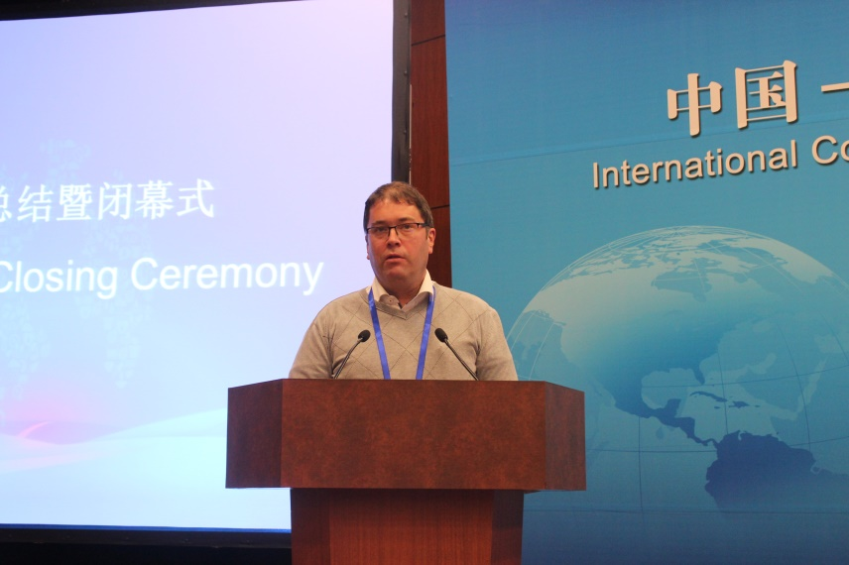
Prof. Miha Humar, Dean of the College of Biotechnology of the University of Ljubljana addressed the closing ceremony.

Prof. Miha Humar highly commended the conference as a cross-discipline seminar focused on forestry for it had sought common ground while shelving differences, built consensus, brainstormed ideas and achieved fruitful results. Prof. Humar said that China is currently in the critical stage of modernization and in the need of improved mutual understanding with other countries. He extended his sincere hope of strengthening exchanges of policy among all relevant countries, improving people-to-people contacts, and making concerted efforts to develop the modernized ideas of “the harmonious co-existence between human and the nature” bridged by “Belt and Road Initiative” development and supported by “16+1” cooperation platform.

Main Achievements of the Conference (Summary of Dr. Xiao Wenfa)
During the two days’ event, government representatives and experts undertook in-depth discussions and exchanges on silviculture, forest ecology environment and protection, forest monitoring and assessment, biological economy of forestry and forestry education and training, while participants of enterprises discussed the approaches to improve industrial, economic and trade cooperation. Heated discussions and exchanges during the conference facilitated the sharing of the status quo and development experiences of forestry, deepened the mutual understanding of research focuses and main challenges, proposed suggestions for collaboration, discussed prospects of cooperation and established the connections among experts and research groups. The information communicated and channels revealed by the conference will become the foundation and bridge for China-CEECs forestry cooperation and make due contributions to the increase of forest resources, the promotion of forest quality and ecosystem functions, the improvement of ecological environment and human well-being, the implementation of Paris Agreement in combating climate change and the realization of Sustainable Development Goals of the United Nations in China as well as in CEECs.

After heated and fruitful discussions during the conference, participants reached the following consensus:

First, there is huge potential for China and CEECs to cooperate in silviculture, forest ecology, environment and protection, forest monitoring and assessment, biological economy of forestry and forestry education and training. Starting from the conference, relevant countries may establish research exchange network, jointly apply for and implement international cooperative research projects, promote the exchanges of researchers and the sharing of research achievements, organize academic events, jointly publish theses and establish associated laboratories, which will concretely promote the pragmatic, efficient and win-win cooperation of “16+1” in forestry research.

Second, China and CEECs enjoy promising future in forestry education and training cooperation. The “16+1” forestry personnel exchanges and capacity building collaboration could be promoted based on the “16+1” forestry research cooperation through the exchanges of experts, scholars and undergraduates and organizing such events as high-level cooperation forums and academic seminars, so as to improve the personnel exchanges between China and CEECs and build talents pool to further “16+1” forestry research cooperation.

This conference focused on “16+1” forestry research cooperation and interdisciplinary exchanges. The participants comprised of officials from the forestry, educational and diplomatic sectors, experts from high-end thin tank, famous academies and professional research institutions and representatives from enterprises, who all have high attainment and rich experiences in their respective professional areas. The topics covered the areas of forestry research, R&D, sharing of results, education cooperation and personnel exchanges, including both theoretical and academic discussions and specific policy advices and practical approaches. Following two days’ dialogues, the consensus had been promoted and the mutual understanding deepened among participants, which strengthened the will of relevant countries in advancing pragmatic cooperation and laid solid foundation for concrete cooperation between China and CEECs.

