Guideline for Country Forestry Report

Dear Sponsored participants to the International Conference on China-CEECs Forestry Research and Education Cooperation,

Welcome to Beijing for the International Conference on China-CEECs Forestry Research and Education Cooperation on October 30-31, 2017 with a Special Session on Business Forum during the conference and also with optional tour to Yiwu City, Zhejiang Province for International Forest Products Fair on November 1!

For information exchange among all 16 CEECs and China, we would like to collect and compile a profile of general information on forestry for each of 16 CEECs and China. With NO LESS THAN 10 pages, such general information consists of forest resources and forest management etc with framework of contents as follows. Maps, tables, figures and boxes are strongly recommended to better illustrate the general status of forestry in your country.

The deadline for submission of the Country Forestry Report is September 30, 2017.

We thank you very much for your kind support and cooperation!

The Conference Organizer
August 4, 2017

**************************************

Guided Contents

1. BRIEF COUNTRY PROFILE SLOVENIA
Slovenia covers 20,273 square kilometres and has a population of 2.06 million. It has borders with Italy, Austria, Croatia and Hungary, and stretches from the Alps in the west to the Pannonian Plain in the east and across the Dinaric Alps to the Mediterranean Sea. In spite of its geographically small size, it is a convergence point for a range of different landscapes, each of which has its own characteristics and unique features. The coastline is only 46.6 km long, but there are 26,000 km of rivers and streams and some 7,500 freshwater springs, including several hundred first-class therapeutic mineral springs.

- FORESTRY AND FOREST
- Forest area
Today the total area of forests is 1.182.278 ha, from which 98.762 ha are protected forests and 9.508 ha od forest reserves.
265,000 ha of forests are certified by the FSC system, which represents more than 20% of the complete forest area in Slovenia, where these are predominantly national forests (235,000 ha). The area according to the national certification scheme PEFC for forests has increased by 20% and now encompasses 50,000 ha of privately owned forests.

Picture 1 Forest area (Data source: Slovenian forest service)

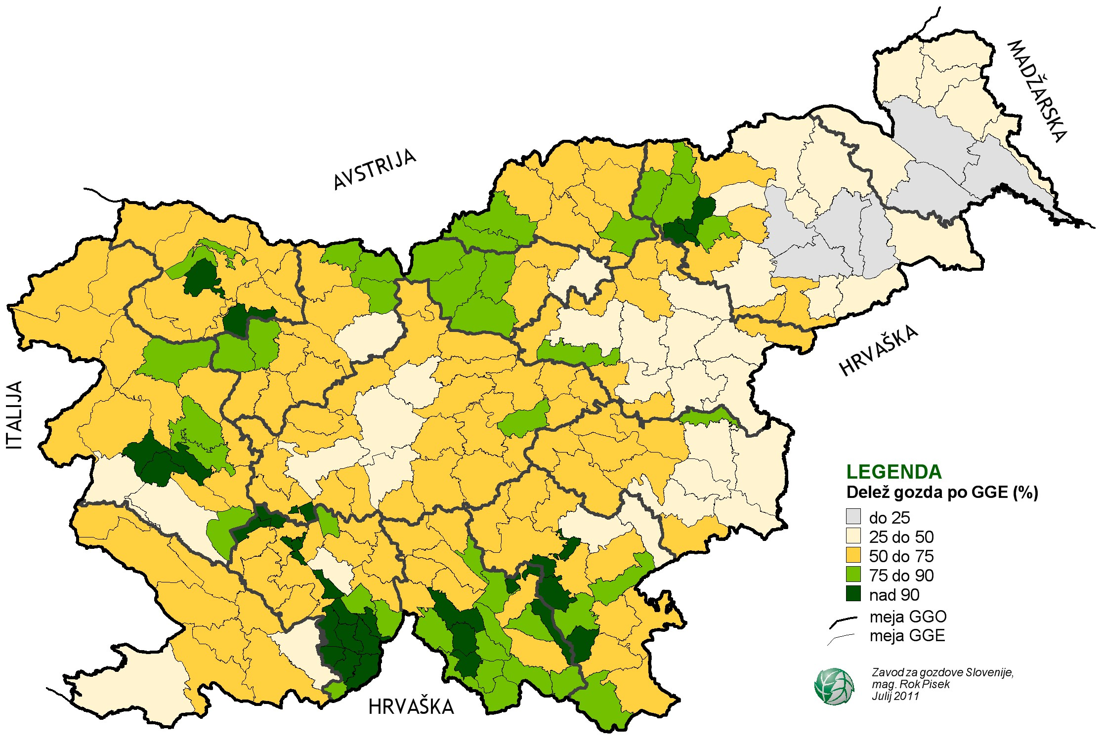
Picture: Share of forests per forest units

- Forest coverage and its change
The main reason for growing of forest land in in last 130years is abandonment of agricultural land. There was only 36.4 % of land covered with forests in 1875, today (according to data from forest management plans) is more than 58 %. The process of overgrowing of agricultural land is more or less finished in last decade but latest date show that the forest area grown for 263 ha in 2016 (Data from Slovenian forestry service).

- Forest classification
Table 1 Forest area
Categories* | Forest area (000 hectares)
 | 1990 | 2000 | 2005 | 2010 | 2015
Primary forest  (virgin forest, forest reserves and protection forests) | 63 | 95 | 111 | 109 | 108
Other naturally regenerated forest | 1 091 | 1 102 | 1 095 | 1 112 | 1106
Planted forest | 34 | 36 | 37 | 32 | 34
TOTAL | 1 188 | 1 233 | 1 243 | 1 253 | 1 248
* based on report for Joint COST Action FACESMAP/UNECE/FAO Enquiry on Forest Ownership in the ECE Region

(4) Forestry structure
No specific data exist on area for individual species as different species coexist in forest stands, however, based on permanent sample plots, percentage of species growing stock in forest stands is well known.
Table 2 Share of tree species in growing stock
Scientific name | Common name | % of adjusted growing stock*
 |  | 1990 | 2000 | 2007 | 2005 | 2010 | 2015
Picea abies | Spruce | 32.97 | 33.39 | 30.94 | 31.64 | 31.16 | 31.11
Fagus sylvatica | Beech | 31.35 | 31.65 | 31.02 | 31.20 | 31.16 | 31.08
Abies alba | Fir | 9.82 | 9.27 | 8.20 | 8.51 | 7.79 | 6.94
Quercus petraea | Oak | 5.84 | 5.09 | 5.75 | 5.56 | 5.63 | 5.58
Pinus sylvestris | Scotch Pine | 4.88 | 4.09 | 4.12 | 4.11 | 4.23 | 4.56
Acer pseudoplatanus | Maple | 2.34 | 3.24 | 3.22 | 3.22 | 3.31 | 3.37
Carpinus betulus | Hornbeam | 2.60 | 1.62 | 2.30 | 2.10 | 2.23 | 2.29
Castanea sativa | Chestnut | 1.53 | 1.52 | 1.89 | 1.78 | 1.63 | 1.60
Pinus nigra | Black Pine | - | 1.16 | 1.57 | 1.45 | 1.61 | 1.68
Ostrya carpinifolia | Hop Hornbeam | 1.05 | 0.82 | 1.25 | 1.13 | 1.44 | 1.60
Remaining |  | 7.63 | 8.15 | 9.75 | 9.29 | 9.82 | 10.20
TOTAL |  | 100.00 | 100.00 | 100.00 | 100.00 | 100.00 | 100.00
Conifers % |  | 52.25 | 49,44 | 46.39 | 47.26 | 46.32 | 45.71
Broadleaves % |  | 47.75 | 50,56 | 53.61 | 52.74 | 53.68 | 54.29
* based on report for Joint COST Action FACESMAP/UNECE/FAO Enquiry on Forest Ownership in the ECE Region
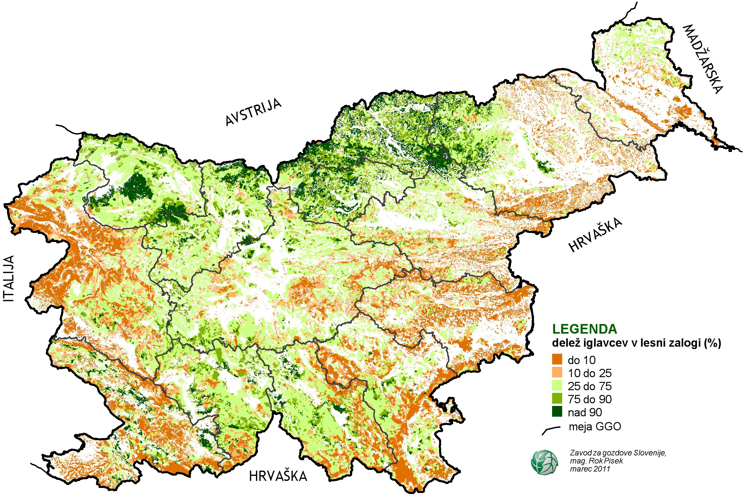
Picture: Share Of coniferous in growing stock (Slovenian forest service)

Table 3 The dynamic variation of the tree species in quantity.
Category / Species name |  |  | Growing stock in forest  (million cubic meters)
Rank | Scientific name | Common name | 1990 | 2000 | 2005 | 2010
1st | Picea abies | Spruce | 90.1 | 111.2 | 118.3 | 126.5
2nd | Fagus sylvatica | Beech | 85.7 | 105.4 | 116.7 | 126.6
3rd | Abies alba | Fir | 26.8 | 30.8 | 31.8 | 31.6
4th | Quercus petraea | Oak | 16.0 | 16.9 | 20.8 | 22.9
5th | Pinus sylvestris | Scotch Pine | 13.3 | 13.6 | 15.4 | 17.2
6th | Acer pseudoplatanus | Maple | 6.4 | 10.8 | 12.1 | 13.4
7th | Carpinus betulus | Hornbeam | 7.1 | 5.4 | 7.9 | 9.1
8th | Castanea sativa | Chestnut | 4.2 | 5.0 | 6.7 | 6.6
9th | Pinus nigra | Black Pine | 0.0 | 3.9 | 5.4 | 6.5
10th | Ostrya carpinifolia | Hop Hornbeam | 2.9 | 2.7 | 4.2 | 5.8
Remaining |  |  | 20.8 | 27.1 | 34.8 | 39.9
TOTAL |  |  | 273.2 | 332.9 | 374.0 | 406.1
* based on report for Joint COST Action FACESMAP/UNECE/FAO Enquiry on Forest Ownership in the ECE Region

(5) Forest stock volume, increment and logging
Forest stock volume
Forest stock volume is growing trough last 60 years. According to latest data from forest management plans the total growing stock was 350.421.000m³ in 2016 or in average 296 m3/ha. If we take in consideration only productive forests (excluding reserves and protected forests) the average forest stock volume was 304 m³/ha.
The similar trend can be seen also for increment. According to latest data (Slovenian forestry service) the increment has grown for 0,7 % in last year, it is estimated to be 8.6655.600 m3 or in average 7,33 m³/ha. If we take in consideration only productive forests (excluding reserves and protected forests) the average increment is higher (7.63 m³/ha)
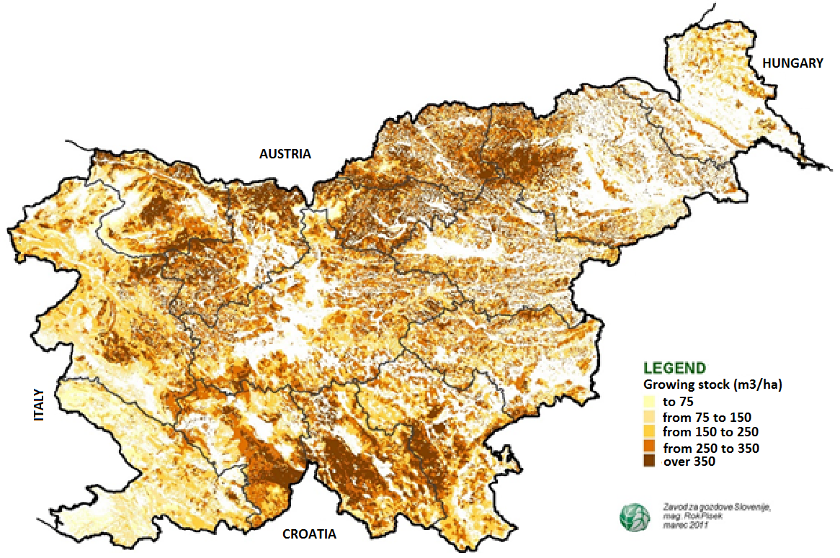
Picture 2 Growing stock in Slovenian forests (Slovenian forest service)

Picture 3 Increment in all forests trough 20 yeas (in m³/ ha) Data source: Statistical office of RS)

(6) Felling operation
According to latest data od Slovenian forest service the total volume of felled timber grows through last years. The main reasons are icebreak in 2014 and bark beetles’ attack which was following the icebreak and is still the biggest problem of forest management in 2017.
Total felling in 2016 was 4.013.124 m3 of coniferous and 2.089.485 of non-coniferous. This represents 94 % of allowable cat according to forest management plans.

Picture 4 Removals by ownership of the forest and by tree species (1000m3), Slovenia, annually (Slovenian forestry service)

Allowable cat (according to forest management plans) has grown from 3.147.770 in 1994 to 6.457.375 m³ in 2016.

Picture 5 Removals by kinds of cutting (m3), Slovenia, annually (Slovenian forestry service)

According to Forest action plan annual felling shouldn’t exceed 75 % of annual increment.

- FOREST MANAGEMENT

Slovenia has an established tradition of planned forest management. Modern principles of forest management in Slovenia are sustainability, imitating the natural cycle in forests (co-natural management) and the multi-purpose nature of the forests (the forests not only produce material assets, but also have environmental and social functions). Public forestry service is performed in all forests, regardless of ownership, by the Slovenian Forest Service, while certain tasks of the public forestry service are also performed by the Slovenian Forestry Institute. Management of private forests is often ineffective because forest holdings are fragmented. Associations of owners, for which timber removal and other works in larger complexes are organised, can significantly contribute to better efficiency of management of private forests. The Chamber of Agriculture and Forestry should also be involved in the training of forest owners for reaching commercial efficiency for forest management.

(1) Institutions associated with forestry

Ministry of Agriculture, Forestry and Food, Dunajska 22, 1000 Ljubljana, http://www.mkgp.gov.si/
As far as administration is concerned, the Ministry of Agriculture, Forestry and Food is responsible for forestry. Forestry matters are dealt within the Forestry, Hunting and Fisheries Directorate.

Responsibilities of the directorate are especially:
- Monitoring and preparation of systematic legal solutions in the field of forestry;
- Monitoring the economic impacts and costs of forestry activities;
- Preparation of economic instruments for financing or co-financing measures in the forests;
- Supervision of implementation of the Forest Act and National Forest Programme.

Forestry Inspection Service as a part of the Inspectorate of the Republic of Slovenia for Agriculture; Forestry, Hunting and Fisheries performing supervision of the implementation of laws, other regulations and acts in the area of forestry.

Slovenia Forest Service, Večna pot 2, 1000 Ljubljana, http://www.zgs.si/
The Slovenian Forest Service is central professional forestry institution and was established by the Government of the Republic of Slovenia (Act on Forests) in 1993. It is financed from the budget of the Republic of Slovenia.
Main tasks of the service are:
- Forest management planning, which are being elaborated and maintained for all forests regardless of ownership;
- Silviculture and forest protection, where the main activities are elaboration of silvicultural plans, marking trees for felling and various forest protection activities including bark beetle control);
- Forestry technique with main tasks of directing and supervising construction of forest roads and providing extension to forest owners for safe work in forests;
- Wildlife management and hunting, including elaboration of hunting management plans.

Slovenian Forestry Institute, Večna pot 2, 1000 Ljubljana, http://www.gozdis.si/
The Slovenian Forestry Institute is the central forestry research organization.
This year marks the 70th anniversary of the establishment of the Slovenian Forestry Institute. The Slovenian Forestry Institute is a public research institute of national importance, which conducts basic and applied research on forests and forest landscapes, forest ecosystems, wildlife ecology, hunting, forest management, and other uses of the resources and services forests provide. The scientific knowledge from these fields helps further the research on forest biodiversity and its management in relation to climate change.

The Institute’s research programme is organized into six departments:
• Department of Forest Ecology
• Department of Forest Physiology and Genetics
• Department for Forest Technique and Economics
• Department of Forest and Landscape Planning and Monitoring
• Department of Forest Yield and Silviculture
• Department of Forest Protection
As part of its research programme and related studies, the Institute also provides forestry and environmental services in the public interest.

Public Forestry Service - Responsibilities Stipulated by the Forest Act (ZG-NPB2)
The Slovenian Forestry Institute intensively monitors forests as part of the public forestry service. This includes surveying and recording forest degradation and damage, providing a diagnostic reporting service, developing an information system for research purposes, and monitoring forestry seeding and nursery activities.
The Institute is also committed to sustainable forest management and the conservation of its biological diversity, as well as to the further development and organization of the Slovenian forestry system and forestry policy.

Public Environmental Service
The Slovenian Forestry Institute’s public environmental service monitors emissions and sinks of GHG resulting from LULUCF. As a signatory of the UNFCCC and EU legislation, Slovenia is required to submit an annual report on GHG emissions and sinks.

Forest protection activities/responsibilities a) quarantine organisms and other invasive alien species in forests as a part of the FPS and b) forest protection of temperate forests and its problems.
Powers Conferred by Public Law under the Forest Act (ZG-NPB2)
• issuing certificates for forest seed and seedlings in accordance with regulations on seed and seedlings
• performing expert and health supervision of forest seed and seedling activities

Publishing
The Slovenian Forestry Institute publishes literature through the Silva Slovenica publishing house. In partnership with the Biotechnical Faculty’s Department of Forestry and Department of Wood Science and Technology, SFI publishes the collection Studia Forestalia Slovenica and the Zbornik gozdarstva in lesarstva (Journal of Forestry and Wood Science).

In recent years, researchers at the Institute established links with numerous renowned research professional institutions from Europe and elsewhere. In last decade about one-third of Institute research efforts are carried in cooperation with foreign partners within European and international programmes and projects.
Research Centre of Slovenian Academy of Science and Arts, Jovan Hadži Institute of Biology, http://bijh.zrc-sazu.si/en/
With a 60 year history, the Jovan Hadži Institute of Biology ZRC SAZU is one of the leading biological research groups in Slovenia. Its researchers perform basic and applied studies of plants and animals at the regional and global scales. Within the institute are three topical units, focusing on basic botany, basic zoology, and applied biology, respectively. The researchers are connected internationally and conduct biodiversity studies on all continents, or provide, through regional applied studies, important guidelines for landscape planning for various clients. The researchers also help teach courses and mentor students at universities in Europe, USA and China.

Biotechnical Faculty, Department of Forestry and Renewal of Forest Resources , Večna pot 83, 1000 Ljubljana, http://www.bf.uni-lj.si/en/

SIDG - Slovenia State Forests PLC, Rožna ulica 39, 1330 Kočevje, http://www.sidg.si/

A new Slovenian state-owned company, Slovenski državni gozdovi d.o.o. (SiDG), has been established by a state forest management law approved by the government on 14 October 2015 and subsequently adopted by the Slovenian Parliament on 2 February 2016. Shortly afterwards the new company was registered (17 March 2016). State forests were earlier managed by the Fund for Agricultural Land and Forests of the Republic of Slovenia

Non-governmental organizations.

Chamber of Agriculture and Forestry of Slovenia, Celovška 135, 1000 Ljubljana, www.kgzs.si/gv/eu-in-svet/english
The Chamber officially represents forest owners and provides extension service. Membership in this organization is mandatory for land owners over certain size of property.

Chamber of Commerce and Industry of Slovenia, Dimičeva 13, 1504 Ljubljana, https://eng.gzs.si/
Branch associations:
- Furniture and Wood Processing Association, Wood Industry cluster /
- Forestry Association,
- Metal processing association,
Federation of Forest Associations of Slovenia, Večna pot 2 1000 Ljubljana http://zgds.si/

Forest Owner Associations’ (FOA), http://slovenski-gozdovi.org/
FOAs in Slovenia have started to emerge and develop after 2001 when the first FOA in Slovenia has been established. FOAs have been recognized as a main opportunity to improve forest management on areas with fragmented ownership and to develop cooperation among small-scale forest owners. In the past 14 years 29 FOAs have been established with more than 4000 members, which is, however, only around 1% of the total number of private forest owners in Slovenia.

(2) Forestry employment
According to the 2005 data of the Statistical Office of the Republic of Slovenia, 2100 people are employed in the field of forestry. They are mostly employed outside of urban centres and they thus help solve the problems of demographically endangered areas.

The total number of workers employed in forestry, woodworking and pulp and paper industry has in the period 2003 to 2012 fallen by 5,800 to 24,000 in 2012. The most significant number of employees decreased in wood processing industry from 13,000 (in 2003) to around 9,200 (in 2012). Forestry has increased its share by 11 percent to 6,000 employees in the structure of employees in the whole forest and wood sector in this period

(3) Forest ownership
The ownership structure of forests (data from SFS forest management plans) shows, that 77,2 % of forests are owned by private persons. Data about the structure of forest owners in not available in detail but industrial private ownership and non-industrial private multiple ownership are very rare in Slovenia. Due to process of denationalisation after 1991 a share of public (state owned and local communes) has decreased to 23 %, which put Slovenia among European countries with the lowest share of national forests.
The average private forest holding is small, with the area of 2,6 ha, and is usually divided into several separated parcels. The size of holdings is decreasing in the process of inheritance. This hampers the management with private forests and reduces interests from owners for forest management. In small forest holding, younger development phases are frequently neglected, which leads to poor growth of stable and quality forest
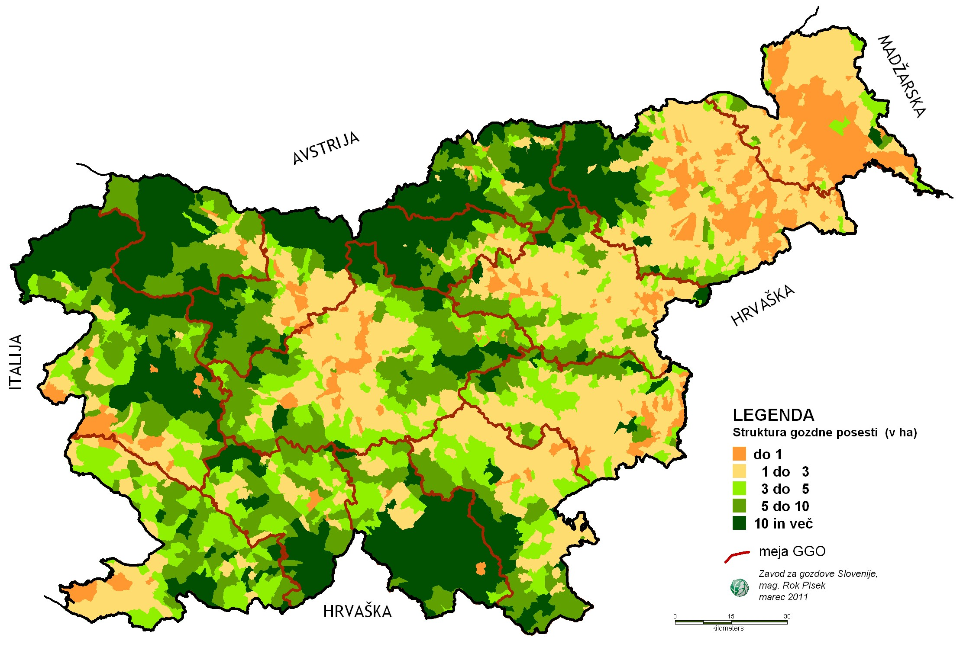
Picture Structure of forest estate (in ha) in Slovenia (Slovenian forestry service)

Most of the privately owned forestland is still managed by natural persons, typically by the owners themselves and their family members. The prevalent working model in the forest is the self-work, though the number of family farms with forests and their round-wood production, gradually decreased in the last 10 years (SURS, 2014). There is an increase in fuelwood production for sale from family farms by the index of 1.20 from 2000 to 2010. By decreasing number of family farms with forests, also the proportion of forests in the total farm size decreased. In 2003 and 2007, the proportion of forests in the total farm size was 1.5%, 2.9%, respectively, less than in 2000. The proportion of farms living from forestry decreased in the last decade. On opposite, there is a rising trend in private companies offering services of forest operations; the proportion of proprietorship and also companies slightly increased indicating slight and slow professionalization of forest work in private forest.

State Forest Enterprises which were responsible for forest management of state-owned forests and planning until 1992 were partly succeeded by the Slovenia Forest Service, and partly by private companies, which gained 20 years-concessions for wood exploitation in state-owned forests, which are officially managed by Farmland and Forest Fund of the Republic of Slovenia (Decree..., 2010). The concessions will expire in 2016. This may bring new impetus in the development of a segment of private forestry, particularly the segment of mountain farms, which had been secured to have the privileged right to apply for the concession for state owned-forests. As a result, more professionalization in terms of technical equipment, work organization and business orientation of private forestry is expected for the larger forest properties in mountain zone.

- Forestry policy
The main legal framework of forestry represents the Forest Act of 1993 with amandments and the National forest program, which was prepared in 2007 for the second time and is based on wide participation of stakeholders.

(5) Investigation and monitoring of forestry resources
Large-scale monitoring/inventory and intensive monitoring as a part of international and national activities (implementation by SFI and SFS):
- at the largescale Level I (at 16 x 16km – ICP Forests, 8x8km, 4km x4km, etc.);
- at Level II (10 plots at process level) according to the ICP Forests.

4. FORESTRY RESEARCH AND EDUCATION
Forestry research is predominately performed on two academic institutions that have developed a strong collaboration and forestry institute. All three were established 70 years ago. They are located in narrower area of the biotechnical campus area what enables tight cooperation and better use of laboratories capacities. The research is these organization is founded by Slovenian research agency and Ministry of Education, Science and Sport, Ministry for Agriculture, forestry and Food; Ministry for Environment, Ministry of Economic Development and Technology, European programs (H2020, Life, Cohesion Fund, European Regional Development Fund & regional programs etc.), networks, and industry.

University of Ljubljana, Biotechnical Faculty, Forestry and Renewable Resources Department (http://www.bf.uni-lj.si/en/forestry/about/) and Department of wood science and technology (http://les.bf.uni-lj.si/en/home/),
Slovenian Forestry Institute (http://en.gozdis.si/), public research institute of national importance and
Pulp and paper institute of Slovenia (http://icp-lj.si/institut/?lang=en).
University and Slovenian Forestry Institute are state owned, while Pulp and paper institute is owned by Slovenian Pulp and Paper industry.

Centre of excellence founded (InnoRenew; https://innorenew.eu/); Centre of excellence was founded based on the cooperation between Slovenian University of Primorska and German Fraunhofer Institute for Wood Research and selected national institutions.

Research Centre of Slovenian Academy of Science and Arts, Jovan Hadži Institute of Biology (http://bijh.zrc-sazu.si/en#v)

- Forestry Education
University of Ljubljana, Biotechnical Faculty, Forestry and Renewable Resources Department and Wood science and technology

Biotechnical faculty is member of University of Ljubljana. The oldest, the biggest and the most excellent Slovenian University. There are 26 faculties and academies at respective University, Biotechnical faculty being one of the biggest. There are approximately 3000 students, and almost 600 employees at Biotechnical Faculty. BF is research oriented faculty, so approximately 50% of bugged came from the research and development

Education at Biotechnical Faculty is organized based on the Bologna principles. BsC studies takes 3 years, while MsC takes additional 2 years. BsC studies in Forestry and Wood Science is organized in two type of programs; professional that is oriented in practice and academic. Students from both programs can continue on the MsC. Last semester in MsC is dedicated to preparation of MsC thesis.

There is one PhD program accredited on Biotechnical Faculty (Biosciences) (http://www.bioznanosti.si/en). There are four faculties from University of Ljubljana participating in this PhD program. This PhD program is Science orientated. Students can chose their program for various Scientific fields; Forestry and Wood Science being one of them. Selection of courses form other programs and Universities is highly stimulated.

The forestry related majors in each forestry universities
Biotechnical Faculty, University of Ljubljana:
- Professional Study Programme in Forestry (BsC) (http://www.bf.uni-lj.si/en/deans-office/study-programmes/professional-study-programmes/forestry/)
- Professional Study Programme in Wood Engineering (BsC) (http://www.bf.uni-lj.si/en/deans-office/study-programmes/professional-study-programmes/wood-engineering/)
- Academic Study Programme in Forestry and Renewable Forest Resources (BsC) (http://www.bf.uni-lj.si/en/deans-office/study-programmes/academic-study-programmes/forestry-and-renewable-forest-resources/)
- Academic Study Programme in Wood Science (BsC) (http://www.bf.uni-lj.si/en/deans-office/study-programmes/academic-study-programmes/wood-science/)
- Academic Study Programme in Landscape Architecture (BsC)( http://www.bf.uni-lj.si/en/deans-office/study-programmes/academic-study-programmes/landscape-architecture/)
- Ecology snd Biodiversity (MsC)( http://www.bf.uni-lj.si/en/deans-office/study-programmes/master-study-programs-second-cycle/ecology-and-biodiversity/#c5229)
- Economics of Natural Resources (MsC)( http://www.bf.uni-lj.si/en/deans-office/study-programmes/master-study-programs-second-cycle/economics-of-natural-resources/)
- Forestry and Forest Ecosystem Management (MsC) (http://www.bf.uni-lj.si/en/deans-office/study-programmes/master-study-programs-second-cycle/forestry-and-managing-forest-ecosystems/)
- Landscape Architecture (MsC)( http://www.bf.uni-lj.si/en/deans-office/study-programmes/master-study-programs-second-cycle/landscape-architecture/)
- Wood Science and Timber Engineering (MsC) (http://www.bf.uni-lj.si/en/deans-office/study-programmes/master-study-programs-second-cycle/wood-science/)
Number of forest-related students and the international students
- Professional Study Programme in Forestry (BsC) 83 students
- Professional Study Programme in Wood Engineering (BsC) 77 students
- Academic Study Programme in Forestry and Renewable Forest Resources (BsC) 86 students
- Academic Study Programme in Wood Science (BsC) 75 students
- Academic Study Programme in Landscape Architecture (BsC) 78 students
- Ecology and Biodiversity (MsC) 46 students
- Economics of Natural Resources (MsC) 17 students
- Forestry and Forest Ecosystem Management (MsC) 23 students
- Landscape Architecture (MsC) 32 students
- Wood Science and Timber Engineering (MsC) 21 students
There are 90 Erasmus (International exchange students at Biotechnical faculty). In general 5% of international students are accepted on the every respective program.

5. FOREST ECONOMICS
(1) Forest contribution to GDP
The share of gross value added of forestry in gross domestic product (GDP) was lower than 1% over the 2003-2012 period. The country’s GDP at current prices amounted to EUR 39,769 million, which is nominally by 3.1% more than in 2015. In volume terms GDP increased by 2.5%.

(2) Forestry - related industrial chain
Non-wood forest product account for 0.5 mio eur annually (vir: SURS)
According to statistical office total round wood production in 2016 was 5.502.000 m3. In structure of roundwood assortments sawn logs were the most important, presenting 54 % of all forest production, followed by firewood with 25 %.

Picture 7 Production of raw wood categories (1000m3), Slovenia, annually

As in 2015, the production of forest wood assortments in Slovenia reached record heights – predominantly due to sanitation harvesting, which was a consequence to the damage caused by bark beetles. The production of forest wood assortments amounted to 5.4 million m³ last year (without bark) last year, which was primarily due to the restoration following the damage caused by bark beetles. Last year, the scope of conifer roundwood amounted to 3.5 million m³ (+14%), and that of deciduous trees to 1.9 million m³ (-5%). The scope of the damage caused by bark beetles last year was the largest recorded in Slovenia history. The increased amounts of harvested conifers were also apparent in the larger quantity of wood acquisitions from private forests, monitored by the Statistical Office of the Republic of Slovenia. A record scope of acquisitions from forest wood assortments from private forests was recorded in 2016, as it increased by 25%, especially due to increased acquisitions of conifers (+35%), on the other hand, acquisitions of deciduous trees decreased (-11%). Conifer wood acquisition coincided with developmental characteristics of bark beetles, as the peak in acquisitions was recorded in the last quarter of the year, which coincides with the dynamics of conifer logs export. Due to increased quantities of conifer logs on the market and a changed structure of assortments, average prices typically decreased during this period. The acquisition of deciduous tree logs increased (+20%), especially beech and oak.

Picture 8 Structure of roundwood production for coniferous and non-coniferous.

Firewood is the most popularly used type of wood fuel, however the estimates for yearly production of firewood are not entirely accurate. Most recent SORS data from 2015 show that households consume 1,600,000tons of wood fuels, which are predominantly firewood. The price of firewood with humidity levels of approx. 20% and lengths between 25 and 33 cm amounted to EUR 134 at the end of the heating season 2016/2017, which is 4% less compared to the beginning of the heating season. The Slovenian Forestry Institute monitors wood fuel prices and regularly publishes them at http://wcm.gozdis.si/cene-lesnih-goriv
Despite an increase in the domestic production of pellets, Slovenia remains a net importer of pellets. According to studies done by Slovenian forestry institute he main consumers of wood pellets are households, followed by larger public buildings and other users. The most recent collection of data on pellet production in Slovenia (concluded by Slovenian forestry institute in May 2017) shows that there are currently 19 producers of pellets in Slovenia – only one of them has a yearly production of above 50,000 tons, and only one of them has a yearly production of between 15,000 and 50,000 tons. The production of pellets in Slovenia was estimated at 115,000 tons for 2016. The production in the last two years has been relatively constant and dependent mostly on available raw materials, as production capacities of individual producers exceed the realised production.
The predominant part of Slovenian pellet production is exported to Italy. Last year, the export of pellets recorded a 14% increase. Italy remains the key export market (over 90% of quantities). Compared to the previous years, 2016 was also marked by a record import of pellets, which exceeded 200,000 tons (+36%). Most pellets are imported from Romania (40%), followed by Bosnia and Herzegovina, Croatia and Austria.
Wood chips are predominantly used for energy purposes, and the Thermal Power Plant Ljubljana is by far the largest consumer with an annual consumption of over 100,000 tons. The consumption of wood chips in the production of wood products (fibre boards, pulp, chemicals) amounts to less than 10% of the total consumption in Slovenia. Wood chips manufacturers are technologically well equipped. According to study done by Slovenian forestry institute there are more than 200 producers of wood chips in Slovenia.
(3) Forest products import and export trade

Total roundwood exports exceeded 3 million m³ in 2016, and the foreign trade surplus for all forest wood assortments exceeded 2.5 million m³. The largest surplus was recorded in conifer logs (1.8 million m³) (Information from Market statement, for R Slovenia in 2017).

Picture 10 Export of Roundwood in last 25 years

Picture 12 Import of Roundwood in last 25 years

The Slovenian furniture industry produced net sales revenues in the amount of EUR 315 million in 2016, which is 10% more compared to 2015. The furniture industry sector ended the fiscal year with a net profit for the second time since 2007, which increased by more than 4 times last year. The share in the net sales revenues structure in foreign markets for the furniture industry NACE C31 amounted to 45% last year. Foreign market sales recorded an increase of 7.6% last year. The most intensive destinations for furniture exports are Germany, Italy and Austria.
Table 3 Import and export of round wood
m³ units (in 1000) | 2010 |  | 2011 |  | 2012 |  | 2013 |  | 2014 |  | 2015
 | Import | Export | Import | Export | Import | Export | Import | Export | Import | Export | Import | Export
Industrial wood total | 194 | 566 | 246 | 808 | 204 | 1028 | 327 | 1198 | 288 | 1965 | 297 | 2303
Industrial wood conifers | 59 | 337 | 104 | 513 | 119 | 670 | 194 | 792 | 154 | 1364 | 185 | 1665
Industrial wood deciduous | 134 | 228 | 142 | 295 | 85 | 358 | 134 | 406 | 134 | 601 | 112 | 638
Firewood total | 113 | 278 | 203 | 334 | 256 | 295 | 247 | 351 | 168 | 420 | 152 | 380
*statistical office RS

Foreign trade trends show an increased activity of Slovenian sawmills, which is a consequence of increased log quantities in the market due to restoration following ice damage, damage caused by bark beetles gradation, market surpluses and lower log prices.

