COUNTRY FORESTRY REPORT FOR SLOVAK REPUBLIC

1. Brief Country Profile
The content includes:
- Land area, population and other information you would like to share with 16+1
members;
Total area: 49 034 km²
Population: 5 421000
Capital: Bratislava (417 ths. inhabitants)
(2) Location;
Slovakia is situated in the geographical center of Europe. The country has no direct access to the sea. The neighboring countries are Czech Republic and Austria in the west, Hungary in the south, Poland in the north and Ukraine in the east.

(3) Natural environment including mountains, rivers, lakes and so on.
Variations in altitude are typical of Slovakia. The difference between the highest peak (2 654 m) and the lowest spots (94 m) above sea level is significant. There are 9 national parks in Slovakia. The total area of forest (forest crop land) in protected areas is 1.15 million ha (Tab.1), which represents almost 60% of the total forest crop land in Slovakia.
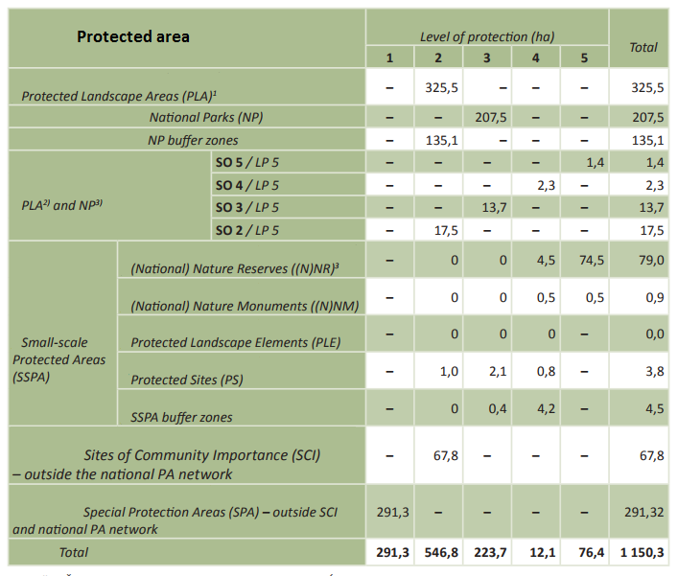

Tab.1: Protected areas by category and level of protection
- Forestry and Forest
- Forest area

The area and change of the forest area in recent years
The area of forest plots has been continually increasing and reached 2 014 731 ha in 2016. In the same period the area of forest crop land, or forest stands respectively, has similarly shown an upward trend and reached 1 942 567 ha (Fig. 1).
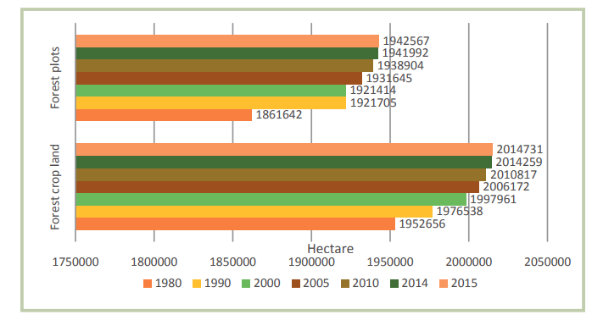

Fig. 1: Trends in forest area and forest crop land (forest stands)

- Forest coverage and its change
Forest coverage, which is calculated as a percentage of the area of forest holdings to the total area of the country, reached almost 41.1% in 2016. In addition to forests on forest land, there is in Slovakia a certain percentage of agricultural and other land covered with stands of forest tree species (so-called white plots). According to the results of the National Forest Inventory and Monitoring SR, which was conducted between the years 2005 and 2006 based on mathematical-statistical sampling methods, the area covered by this type of forest vegetation represented almost 275 000 ha (with an accuracy of ±3.7%). Thus the country’s forest coverage computed as the proportion of forest on both forest and non-forest land, compared to the total area of Slovakia stands at 44.3% ±0.4%.

- Forest classification

The area of each forest classification and its change Basis of classification such as the primary forest, plantation.
At present, the actual age structure of Slovak forests varies considerably from the optimal balanced structure. The above desirable is the area of forests in age classes 1, 8, 9 and 15+. Approximately optimal (normal) is the area of other mature (rotation) forests in the age classes 10 to 14. Below the optimal area are mainly younger forests 11-70 years old which fall into the 2nd to 7th age class. From the15th age class upwards the majority of forests are either protection or special-purpose forests which are under specific management restrictions and subject to nature conservation interest (Fig. 2 and 3).

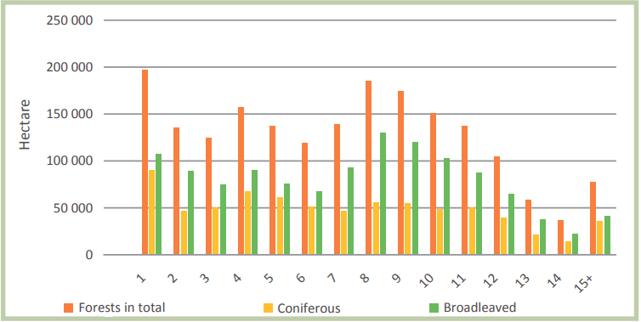

Fig. 2: Forest area by age class

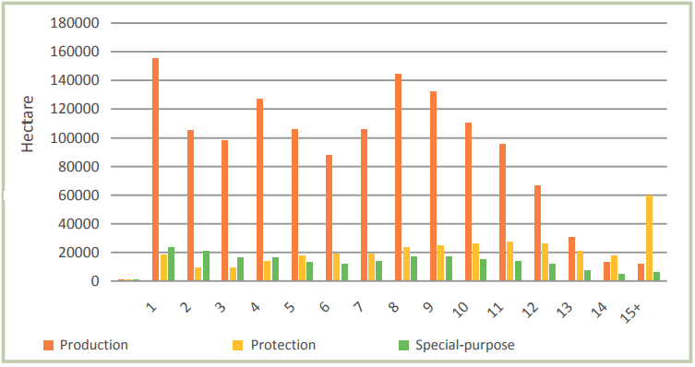

Fig.3: Forest area by age class and main forest category

(4) Forestry structure

The basic situation of the tree species composition such as the area and percentage for the main tree species;
Slovak forests have a rather diverse tree species composition (Tab.2). The most abundant tree species include beech (33.2%), spruce (23.4%), and oaks (10.6%). The broadleaved species prevail and comprise 62.2% of Slovak forests.

2016 – Trees species composition (%)
European beech | 33,2
Norway Spruce | 23,4
English and sessile oaks | 10,6
Scots pine | 6,8
Hornbeam | 5,9
Silver fir | 4,1
European larch | 2,5
Turkey oak | 2,5
Dwarf pine | 1,1
Σ Broadleaves | 62,2
Σ Conifers | 37,8
Tab. 2: Main tree species of Slovak forests (%)

The dynamic variation of the tree species in quantity.
Species composition of forests in Slovakia changes over time (Tab. 3). The percentage of conifers has steadily decreased which is most apparent in the case of spruce the presence of which, due to harmful agents, has declined by 2.9% since 2005.
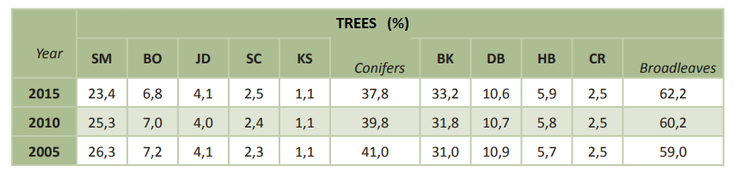

Tab. 3: Main tree species of Slovak forests (%). Key: SM – Norway spruce, SC – European larch, BO – Scots pine, JD – Silver fir, KS – Dwarf pine, BK – European beech, DB – English and sessile oaks, HB – Hornbeam, CR – Turkey oak.

(5) Forest stock volume, increment and logging

The dynamic variation of the forest stock volume, increment and logging
The growing stock in Slovak forests is gradually increasing as indicated by trends and actual age structure of forests. In 2015, the growing stock reached 478.12 million m³ of timber inside bark. The average stock was 247 m³ of timber inside bark per ha. If growing stock by groups of tree species is assessed, we observe an increasing trend in the stock of broadleaved species volume of which reached 275.9 million m³ in 2015, an increase of 17.9% compared to 2005 (Fig.4). Conversely, the growing stock of coniferous species has been gradually decreasing since 2010, mainly due to frequent calamitous events in coniferous forests (spruce forests in particular) caused by wind and followed by outbreaks of biotic harmful agents (bark beetles). The total current increment in 2015 reached 12.1 million m³ or 6.32 m³ per 1 ha of forest crop land.
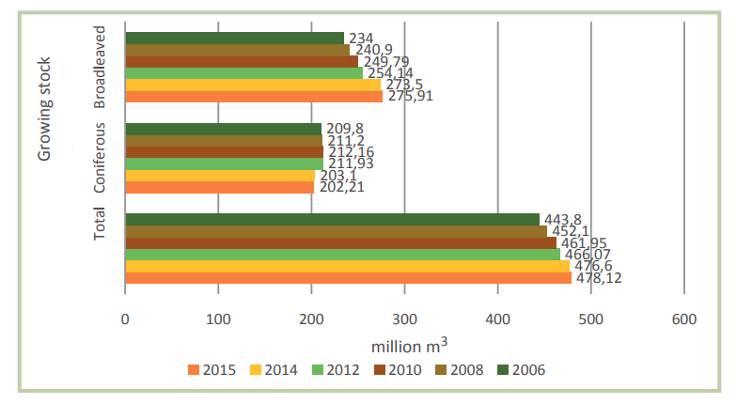

Fig.4: Growing stock in total and by main groups of tree species

(6) Felling operation

The total volume of timber felled in recent 10 years;
Felling volumes are long term increasing in Slovakia. Since 1990, annual felling volume grew from 5.28 million m³ to 9.14 million m³ in 2015, which is a 73% increase. As in the case of steadily increasing growing stock and total current increment, a current increase in felling opportunities and the resulting increase in actual felling volumes is primarily related to the age structure of Slovak forests. Actual conduct of planned intentional intermediate and regeneration fellings (up to the level of acceptable volumes) is complicated mainly by the frequent need for incidental (calamitous) felling.
Since 1990, the rate of incidental (calamitous) felling from the total volume of realized felling has been fluctuating between 42% and 65% (from 1.8 million m³ to 6.5 million m³ per year). This unfavorable trend gained further momentum after 2004 following the windstorm in November 2004, especially due to gradation of pests (bark beetles) in coniferous (spruce in particular) forests. Compared to the beginning of the 1990’s, the volume of salvaged calamitous timber reached in some post 2004 years 2-3 times the level of the 1990’s. Incidental (calamitous) felling has a detrimental impact on the sustainable exploitation of the available forest resource. Owners and forest managing enterprises are obliged by law to remove calamitous timber immediately. Subsequently, planned felling volumes are routinely being exceeded, mostly in 2005 by almost 50%, in 2008 by over 25% and in 2010 by almost 20% (Fig.5).
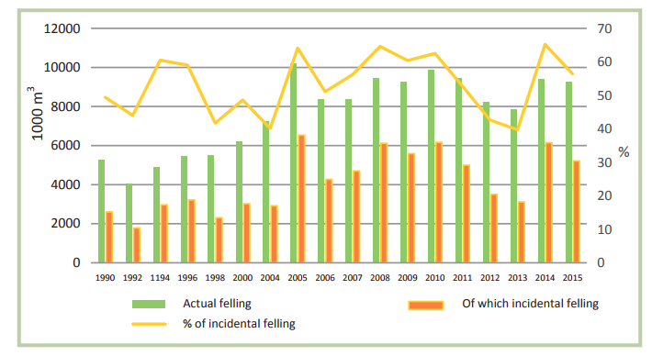

Fig.5: Actual felling volumes, proportion of incidental (calamitous) felling and % of incidental (calamitous) felling

The planned felling volume in the next 10 years.
In the coming decades, the currently over-represented age ranges (area and volume of wood stock) will be shifted to the age of felling. It is therefore assumed that the volume of total fellings will gradually increase over the next 30-40 years.

- Forest Management
- Institutions associated with forestry

Governmental organizations;
The Ministry of Agriculture and Rural Development of the Slovak Republic is the supreme national authority on forests. In military forests and forests of national defence importance, the state supervision of forestry was executed by the Ministry of Defence of the Slovak Republic through its Forestry and Hunting Office.

Non-governmental organizations.
The National Forest Centre provides for the forest sector services in the areas of forest research, education, public relations, public procurement of forest management programes. It comprises four specialized institutes: Forest Research Institute, Institute for Forest Consulting and Education, Institute for Forest Resources and Information, and Forest Management Planning Institute. In 2015, there were the following interest groups and associations in Slovakia: Slovak Forestry Chamber; Slovak Hunting Chamber; Association of Forest Sector Employers; and Association of Non-state Forest Owners which includes the Slovak Union of Diocese Forests, Slovak Association of Municipal Forests, Union of Owners of Private, Community and Municipal Forests of the Banská Bystrica Region, and the Union of Regional Associations of Non-state Forest Owners.

(2) Forestry employment
The number of employees in forestry;
The dynamic variation of the number of employees in forestry.

Indicator | Unit | Year
 |  | 2010 | 2011 | 2012 | 2013 | 2014 | 2015
Workforce (employees) | Thousands of person | 21 | - | 21 | 20 | 20 | 19
Timber processing industry | Thousands of person | 22,49 | - | 21,04 | 17,55 | 21,57 | 22,09
Tab. 4: Number of employees in sectors related to forestry. Source: Statistical Office of SR – Slovstat databases. Ministry of Economy of the SR (Timber processing industry).

(3) Forest ownership

The area and percentage of the forest ownership including private and state owned and public forest;
The structure and trends in forest ownership and management are provided in Fig. 6. In 2015, the state owned 773 801 ha of forest crop land, 39.8 % of the national forest crop land area. State enterprises managed 1 035 344 ha of forest, or 53.3 % of the total area. There were 358 743 ha of forest crop lands with unknown owners (18.5 %).

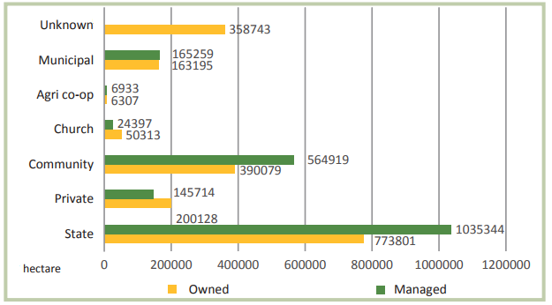

Fig.6: Structure of forest ownership and management in 2015

The dynamic change in the proportion of the forest ownership.
The process of transference of ownership and tenure rights to forest land has yet to be completed. Forest land that is the subject of transference of ownership and tenure rights is handed to its owners by state forest enterprises. Unreturned forest land comprises land of natural and legal entities which have already claimed their ownership rights to forest land and are currently dealt with, land owned by persons who have yet to claim it and persons whose residence is unknown.
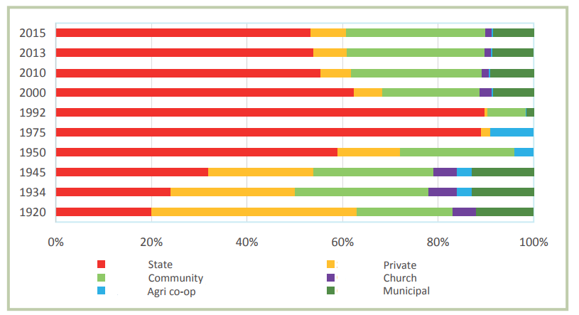

Fig.7: Basic data on forests managed by non-state enterprises
- Forestry policy

A brief description of the Forest-related policies and laws
Existing updated set of forest policy documents and generally binding legal regulations in the field of forestry:
- the National Programme on the Utilization of Available Timber Resource, approved by the Decree of the Slovak Government No 492 from 21 August 2013;
- the Action Plan of the National Programme on the Utilization of Available Timber Resource, approved by the Decree of the Slovak Government No 442/2014 from 18 December 2014;
- the Action Plan of the National Forest Programme for 2014-2020, approved by the Decree of the Slovak Government No 697/2015 from 16 December 2015;
- the Strategic Development Plan for the Agriculture Sector of the Slovak Republic 2013-2020.
The National Council of the Slovak Republic has approved the Act No 182/2014 Coll which amends the Act No 326/2005 Coll on forests in the wording of the pursuant regulations and which amends certain other laws. The European Commission approved in 2015 the Rural Development Programme of the Slovak Republic 2014-2020.

(5) Investigation and monitoring of forestry resources
Investigation and monitoring of forestry resources in Slovakia is ensured by National forest inventory and monitoring.
The main task of this monitoring is to obtain and evaluate information on quantitative and qualitative variables characterizing the status of forest ecosystems.
The partial forest monitoring system in Slovakia, as well as the European forest monitoring system, has two basic components:
- Large-scale, extensive monitoring (I. Level)
- Intensive monitoring (II. Level)
At present, there are 112 permanent inventory plots (so-called TMP) in Slovakia spread in 16x16 km net (extensive monitoring I. level) and 7 permanent inventory plots for selected forest ecosystems (intensive monitoring II. level). These plots are part of European monitoring system. Important advantage of national forest monitoring system is full compatibility with European programs.

Monitoring net I. and II. level may be considered for main method for status detection of forest in Slovakia. On inventory plots, the following information is collected:
- investigation of defoliation and tree damage caused by biotic or abiotic harmful agents,
- evaluation of leaf and needle sample analyzes,
- measurement of quantity and quality of atmospheric deposition,
- measurement of increment changes,
- vegetation valuation,
- soil solution measurement,
- meteorological measurements,
- measurement and assessment of air quality,
- assessment of visible ozone damage,
- phenological evaluations.
Locations of inventory plots for monitoring are shown on the Picture 1.

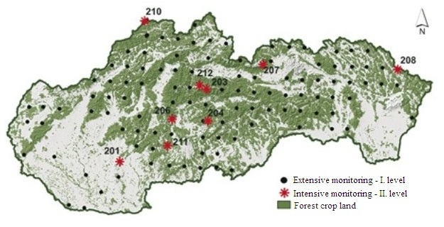
Picture 1: Inventory plots

4. Forestry Research and Education
- Forestry Research
- National Forest Centre Zvolen
- Institute of Forest Ecology of Slovak Academy of Science in Zvolen

Forest related institutions
- Ministry of Agriculture and Rural Development of the Slovak Republic
- Ministry of Economy of the Slovak Republic
- Ministry of Defence of the Slovak Republic
- Association of employers in Forestry of Slovak Republic
- Association of Non-State Forests owners
- Slovak Forestry Chamber, Zvolen
- Slovak Hunting Union, Bratislava
- State enterprise Forests of Slovak Republic, Banska Bystrica
- Forest and agricultural Property Ulic, State enterprise
- State Forests of TANAP, Tatranska Lomnica
- Military Forests and Estates of Slovak Republic, State enterprise Pliesovce

- Forestry Education
- Secondary Forestry and Wood Technology School, Liptovsky Hradok
- Secondary schools in Banska Stiavnica, Poltar, Bijacovce and Presov
- School Forests in Cemjata
- Secondary School of Forestry Tvrdosin

List of forestry universities
- Technical University in Zvolen/ Faculty of Forestry

The forestry related majors in each forestry universities
Accredited study programmes at Technical University in Zvolen / Faculty of forestry:
BSc. programmes:
- Forestry (in the study field Forestry)
- Applied Zoology and Game Management (in the study field Game Management)
MSc. programmes
- Forestry (in the study field Forestry)
- Forest Ecology (in the study field Forestry)
- Applied Zoology and Game Management (in the study field Game Management)
- Geoinformatics and Mapping Technologies in Forestry (in the study field Forestry)

Number of forest-related students and the international students
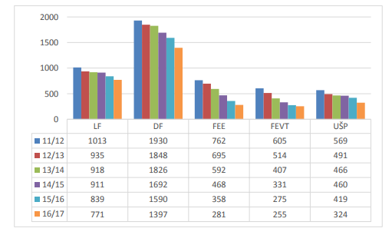

Fig 8: Evolution of the number of students at faculties Technical University in Zvolen

5. Forest economics
(1) Forest contribution to GDP

Gross added value of forestry, the country’s GDP and the share of forestry’s contribution;

Indicator | Unit | Year
 |  | 2010 | 2012 | 2013 | 2014 | 2015
GDP in current prices | billion € | 67,39 | 72,42 | 73,84 | 75,56 | 78,07
thereof Forest sector | billion € | 0,22 | 0,26 | 0,28 | 0,31 | 0,28
GDP growth | % | 5,6 | 2,8 | 2,0 | 2,3 | 3,3
Investments in current prices | million € | 14910 | 15405 | 15292 | 15766 | 17969
thereof Forest sector | million € | 32 | 28 | 24 | 37 | 39
Average monthly earnings | € | 769 | 805 | 824 | 858 | 883
thereof Forest sector | € | 676 | 862 | 907 | 958 | 996
Workforce productivity out of the added value | € | 27543 | 29610 | 29958 | 30799 | 29099
thereof Forest sector | € | 19693 | 27196 | 29797 | 34463 | 34953
Tab. 5: Key macroeconomic indicators by country and sector. Source: Statistical Office of SR – Slovstat databases; National Bank of Slovakia;

(2) Forestry - related industrial chain

Yield and output value of wood and non-wood forest products
The 2015 economic result reached the sum of 44.8 million €. The fall in compare to 2014 (in both state and non-state forest sector) was caused by lower felling volumes resulting in lower timber supply and also partially by the increase in silviculture costs (Tab.6).
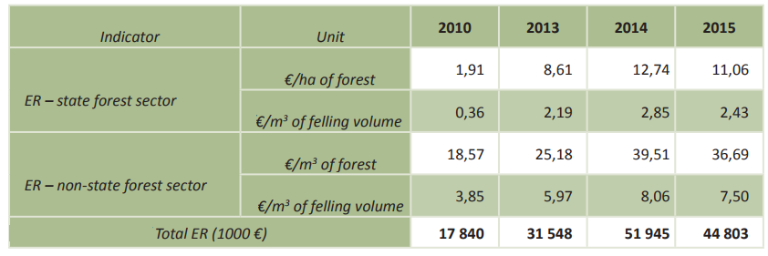

Tab.6: Economic results by unit and in total

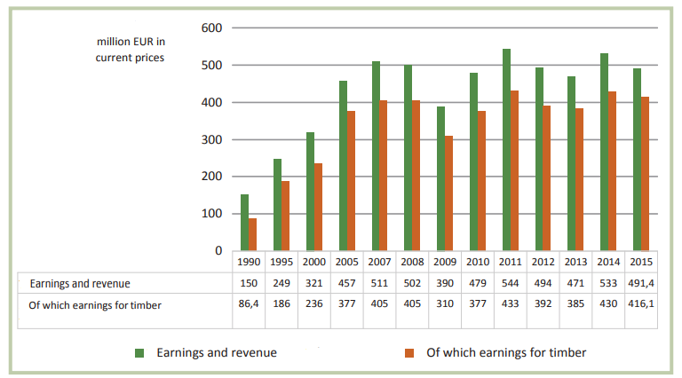

Fig.7: Sectoral earnings and revenue from forestry

(3) Forest products import and export trade
Import volume, import value, export volume, export value for all wood and non-wood forest products since 2010 (or 2000)
The timber processing industry in Slovakia has processing capacities that are fully sufficient for the entire volume of harvested coniferous timber in Slovakia.
A higher demand for conifer roundwood and broadleaved pulpwood still prevails and must be partially satisfied by import. Historically pulp and papermaking industries belong to the best performing industries of the national economy. The companies are grouped in the Pulp and Paper Industry Federation of the Slovak Republic.
At present, processing capacity of the operating units is less than 500 000 m³ of broadleaved roundwood. There is a gap in the market in the production of wood products with high added value, such as sliced veneer, peeled veneer, plywood and fibrewood for the furniture making industry. Slovakia still adequately processes only a small volume of the highest quality log grades produced in Slovak forests. The average production of these grades could be around 40 000 m³ from coniferous species and 260 000 m³ from broadleaved species. Owing to a lower effectiveness of timber processing, domestic processing facilities are oft en only subcontractors of foreign companies.

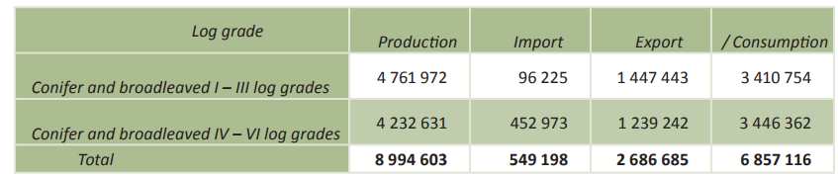

Tab.7: Production, import, export and consumption of raw timber in 2015

