International Conference on China-CEECs
Forestry Research and Education Cooperation

October 30-31, 2017
Beijing, China

Country Forestry Report
SERBIA

Prof.dr Sasa Orlovic, Dr Dejan Stojanovic, Dr Mirjana Stevanov, Igor Djukic, Lazar Pavlovic

1. Brief Country Profile
The Republic of Serbia is a landlocked country situated at the Southeast Europe and covers a total of 88,361 km², which places it at 113th place in the world. Total population of the country is 7,186,862 and the overall population density is medium, as it stands at 92.8 inhabitants per square kilometer. Serbia has two autonomous provinces, Vojvodina in the north, and Kosovo and Metohija in the south.
Demography
The number of live births in the Republic of Serbia in 2016 was 64,734, while the number of deaths was 100,834. The natural increase was -36,100. In the period from 2006 to 2016, the number of inhabitants in the Republic of Serbia has been reduced by approximately 385,000. Serbia has been enduring a demographic crisis since the beginning of the 1990s, with a death rate that has continuously exceeded its birth rate, and a total fertility rate of 1.43 children per mother, one of the lowest in the world. Serbia subsequently has one of the oldest populations in the world, with the average age of 42.9 years. One fifth of all households consist of only one person, and just one-fourth of four or more persons. Average life expectancy in Serbia is 74.8 years.
Serbs with 5,988,093 are the largest ethnic group in Serbia (83% of the total population excluding Kosovo). With a population of 253,899, Hungarians are the largest ethnic minority in Serbia, suited predominately in northern Vojvodina and representing 3.5% of the country's population (13% in Vojvodina). Romani population stands at 147,604 according to the 2011 census but unofficial estimates place their actual number between 400,000 and 500,000. Bosniaks with 145,278 are concentrated in Raška (Sandžak), in the southwest. Other minority groups include Croats, Slovaks, Albanians, Montenegrins, Vlachs, Romanians, Macedonians and Bulgarians. Chinese, estimated at about 15,000, are the only significant immigrant minority.
Nationality | Number | Share
Serbs | 5.988.093 | 83,32%
Hungarians | 253.899 | 3,53%
Romani | 147.604 | 2,05%
Bоsniaks | 145.278 | 2,02%
Croats | 57.900 | 0,81%
Slovaks | 52.750 | 0,73%
Montenegrins | 38.527 | 0,54%
Vlachs | 35.330 | 0,49%
Romanians | 29.332 | 0,41%
Yugoslavians | 23.303 | 0,32%
Macedonians | 22.755 | 0,32%
Muslims | 22.301 | 0,31%
Bulgarians | 18.543 | 0,26%
The others* | 75.087 | 1.05%
Unexplained | 160.346 | 2,23%
Unknown* | 81.740 | 1,14%
Total | 7.186.862 | 100%

The official language is Serbian, native to 88% of the population. Serbian is the only European language with active digraphia, using both Cyrillic and Latin alphabets.
Recognized minority languages are: Hungarian, Bosnian, Slovak, Croatian, Albanian, Romanian, Bulgarian and Rusyn. All these languages are in official use in municipalities or cities where the ethnic minority exceeds 15% of the total population. In Vojvodina, the provincial administration uses, besides Serbian, five other languages (Hungarian, Slovak, Croatian, Romanian and Rusyn).
Serbia is a parliamentary republic, with the government divided into legislative, executive and judiciary branches.

Geography
As it mentioned before, Serbia is a landlocked country situated at the crossroads of Central and Southeast Europe, in the southern Pannonian Plain and the central Balkans
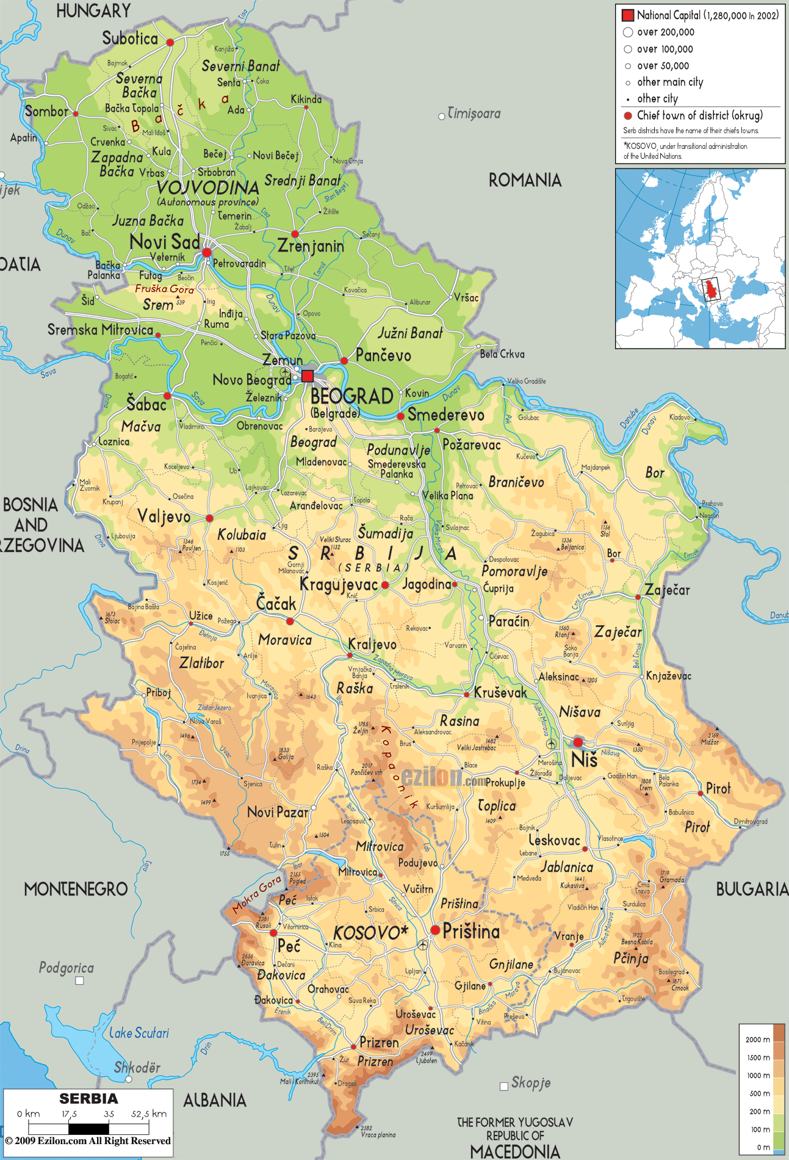 | 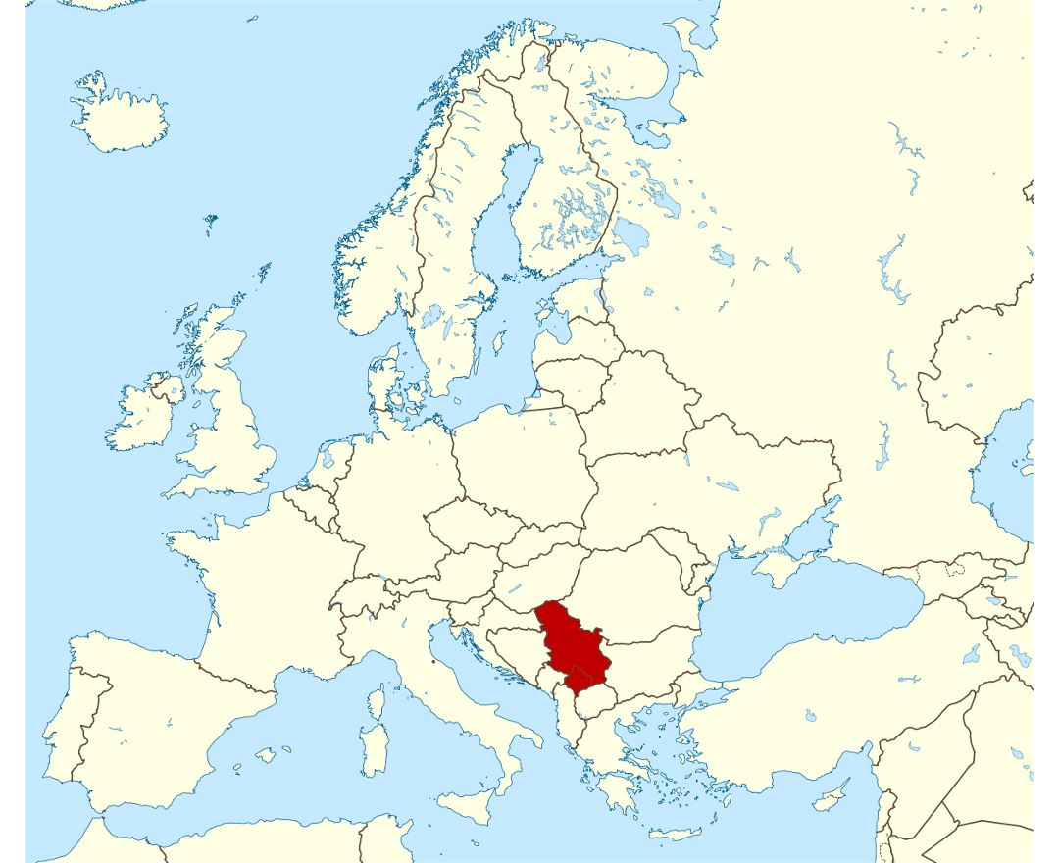

Serbia lies between latitudes 41° and 47° N, and longitudes 18° and 23° E. The Pannonian Plain covers the northern third of the country (Vojvodina and Mačva) while the easternmost tip of Serbia extends into the Wallachian Plain. The terrain of the central part of the country, with the region of Šumadija at its heart, consists chiefly of hills traversed by rivers. Mountains dominate the southern third of Serbia. Dinaric Alps stretch in the west and the southwest, following the flow of the rivers Drina and Ibar. The Carpathian Mountains and Balkan Mountains stretch in a north–south direction in eastern Serbia. Ancient mountains in the southeast corner of the country belong to the Rilo-Rhodope Mountain system. Elevation ranges from the Midžor peak of the Balkan Mountains at 2,169 metres (7,116 feet) (the highest peak in Serbia, excluding Kosovo) to the lowest point of just 17 metres (56 feet) near the Danube river at Prahovo. The largest lake is Đerdap Lake (163 square kilometres or 63 square miles) and the longest river passing through Serbia is the Danube (587.35 kilometres or 364.96 miles).

Climate
The climate of Serbia is under the influences of the landmass of Eurasia and the Atlantic Ocean and Mediterranean Sea. With mean January temperatures around 0 C (32 F), and mean July temperatures of 22°C (72°F), it can be classified as a warm-humid continental or humid subtropical climate. In the north, the climate is more continental, with cold winters, and hot, humid summers along with well distributed rainfall patterns. In the south, summers and autumns are drier, and winters are relatively cold, with heavy inland snowfall in the mountains.
Differences in elevation, proximity to the Adriatic Sea and large river basins, as well as exposure to the winds account for climate variations. Southern Serbia is subject to Mediterranean influences. The Dinaric Alps and other mountain ranges contribute to the cooling of most of the warm air masses. Winters are quite harsh in the Pešter plateau, because of the mountains which encircle it. One of the climatic features of Serbia is Košava, a cold southeastern wind which starts in the Carpathian Mountains and follows the Danube northwest through the Iron Gate where it gains a jet effect and continues to Belgrade and can spread as far south as Niš.
The average annual air temperature for the period 1961–1990 for the area with an altitude of up to 300 m (984 ft) is 10.9°C (51.6 F). The areas with an altitude of 300 to 500m (984 to 1,640 ft) have an average annual temperature of around 10.0 C (50.0 F), and over 1,000 m (3,281 ft) of altitude around 6.0 C (42.8 °F). The lowest recorded temperature in Serbia was −39.5 C (−39.1 F) on 13 January 1985, Karajukića Bunari in Pešter, and the highest was 44.9 C or 112.8 °F, on 24 July 2007, recorded in Smederevska Palanka.
Serbia is one of few European countries with very high risk exposure to natural hazards (earthquakes, storms, floods, droughts). It is estimated that potential floods, particularly in areas of Central Serbia, threaten over 500 larger settlements and an area of 16,000 square kilometers. The most disastrous were the floods in May 2014, when 57 people died and a damage of over a 1.5 billion euro was inflicted.

Hydrology
Almost all of Serbia's rivers drain to the Black Sea, by way of the Danube river. The Danube, the second largest European river, passes through Serbia with 588 kilometers (21% of its overall length) and represents the largest source of fresh water. It is joined by its biggest tributaries, the Great Morava (longest river entirely in Serbia with 493 km of length), Sava and Tisza rivers. One notable exception is the Pčinja which flows into the Aegean. Drina river forms the natural border between Bosnia and Herzegovina and Serbia, and represents the main kayaking and rafting attraction in both countries. Due to configuration of the terrain, natural lakes are sparse and small; most of them are located in the lowlands of Vojvodina, like the aeolian lake Palić or numerous oxbow lakes along river flows (like Zasavica and Carska Bara). However, there are numerous artificial lakes, mostly due to hydroelectric dams, the biggest being Đerdap (Iron Gates) on the Danube with 163 km² on the Serbian side (a total area of 253 km² is shared with Romania) as well as the deepest (with maximum depth of 92 m); Perućac on the Drina, and Vlasina. The largest waterfall, Jelovarnik, located in Kopaonik, is 71 m high. Abundance of relatively unpolluted surface waters and numerous underground natural and mineral water sources of high water quality presents a chance for export and economy improvement; however, more extensive exploitation and production of bottled water began only recently.

Environment
Serbia is a country of rich ecosystem and species diversity – covering only 1.9% of the whole European territory Serbia is home to 39% of European vascular flora, 51% of European fish fauna, 40% of European reptile and amphibian fauna, 74% of European bird fauna, 67% European mammal fauna. Its abundance of mountains and rivers make it an ideal environment for a variety of animals, many of which are protected including wolves, lynx, bears, foxes and stags. There are 17 snake species living all over the country, 8 of them are venomous. Serbia is home to highly protected owl species. In the northernmost part of Vojvodina plain, in the city of Kikinda, a number of endangered 145 long-eared owls is noted, making this town the world's biggest settlement of these species. Serbia is considerably rich with threatened species of bats and butterflies.Mountain of Tara in western Serbia is one of the last regions in Europe where bears can still live in absolute freedom. Serbia is also home to about 380 species of bird. In Carska Bara, there are over 300 bird species on just a few square kilometers. Uvac Gorge is considered one of the last habitats of the griffon vulture in Europe. There are 377 protected areas of Serbia, encompassing 4,947 square kilometers or 6.4% of the country. The "Spatial plan of the Republic of Serbia" states that the total protected area should be increased to 12% by 2021. Those protected areas include 5 national parks (Đerdap, Tara, Kopaonik, Fruška Gora and Šara Mountain), 15 nature parks, 15 "landscapes of outstanding features", 61 nature reserves, and 281 natural monuments. Air pollution is a significant problem in some area, due to work of large copper mining and smelting complex, and where oil and petrochemical industry is based. Some cities suffer from water supply problems, due to mismanagement and low investments in the past, as well as water pollution (like the pollution of the Ibar River rom the Trepča zinc-lead combinate, affecting the city of Kraljevo, or the presence of natural arsenic in underground waters in Zrenjanin).
With 29.1% of its territory covered by forest, Serbia is considered to be a middle-forested country, compared on a global scale to world forest coverage at 30%, and European average of 35%. The total forest area in Serbia is 2,252,000 ha (1,194,000 ha or 53% are state-owned, and 1,058,387 ha or 47% are privately owned) or 0.3 ha per inhabitant. The most common trees are oak, beech, pines and firs.

- Forestry and Forest
Forest area
The main challenges of Serbia forestry has are related to the poor condition of forests (a large proportion of forest of coppice origin, a low annual increment, unfavourable age structure) uneven distribution of forest cover, poor road infrastructure essential for the use and protection of forests, and organizational problems in management related to the large number of private forest owners. Based on these challenges, the increase of forest cover and its optimization is of great importance to forestry, and for the entire society. Increasing forest cover concerning the protective functions of forests is probably of greatest importance.
According to the Spatial Plan of Serbia 2010-2020, the forest area of the Republic of Serbia amounts 30.6%. That area under forest cover ranks it as an average afforested country in world terms (Figure 1). Dominating tree species is European beech (Fagus sylvatica) and dominant group is oak (Quercus petrea, Q. robur, Q.cerris, Q. frainetto) (NFI, 2009). Serbia has high special diversity. At its territory it can be found 3662 vascular plant taxa (about 39% of the vascular flora of Europe) and 78 tree species.
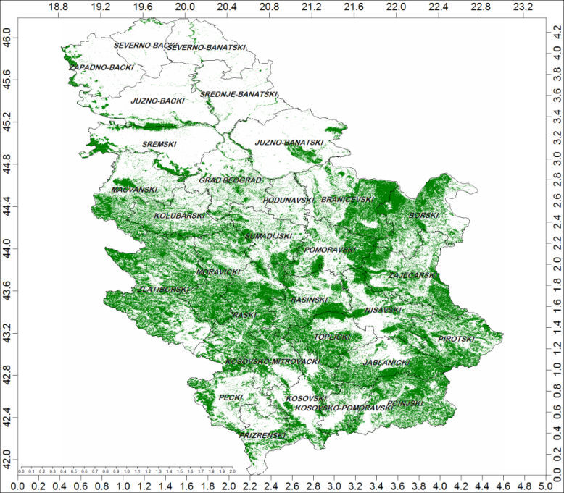
Figure 1 Forest cover in Republic of Serbia (Stojanović et al., 2015)
Forest coverage and its change
In last decades slight increase of forest cover can be noticed (Table 1).
Table 1 Overview of area covered with forest trees and changes at the level of the Republic, regions and districts in the period 2000-2013. Gray indicates the districts where the decrease of forest cover was registered (Stojanović et al., 2015).
District | District area (ha) | Forest cover 2000 (%) | Increase (2000-2013) (%) | Decrease (2000-2013) (%) | Summary of changes (2000-2013) (%) | Absolute change in forest cover (2000-2013) (ha)
BOR | 351733 | 38,618 | 0,002 | 0,004 | -0,002 | -789
BRANIČEVO | 386780 | 38,410 | 0,003 | 0,002 | 0,001 | 481
THE CITY OF BELGRADE | 323713 | 16,612 | 0,004 | 0,006 | -0,002 | -796
ZAJEČAR | 363255 | 39,293 | 0,002 | 0,003 | 0,000 | -88
WESTERN BAČKA | 248456 | 6,555 | 0,002 | 0,006 | -0,004 | -1031
ZLATIBOR | 616114 | 43,389 | 0,011 | 0,002 | 0,008 | 5165
JABLANICA | 276826 | 42,601 | 0,006 | 0,004 | 0,002 | 656
SOUTHERN BANAT | 424254 | 8,009 | 0,003 | 0,003 | -0,001 | -293
SOUTHERN BAČKA | 402448 | 6,957 | 0,003 | 0,006 | -0,003 | -1273
KOLUBARA | 247463 | 29,777 | 0,002 | 0,002 | 0,000 | -14
KOSOVO | 312447 | 29,033 | 0,004 | 0,007 | -0,003 | -797
KOSOVO-MITROVAC | 205430 | 35,979 | 0,006 | 0,005 | 0,001 | 192
KOSOVO-POMORAVLJE | 142930 | 26,562 | 0,009 | 0,012 | -0,003 | -484
MAČVA | 326808 | 26,600 | 0,002 | 0,002 | 0,000 | -22
MORAVA | 302495 | 46,162 | 0,008 | 0,002 | 0,006 | 1798
NIŠAVA | 273459 | 32,558 | 0,003 | 0,003 | 0,000 | 70
PEĆ | 255971 | 22,962 | 0,006 | 0,010 | -0,004 | -1140
PIROT | 276296 | 41,139 | 0,005 | 0,003 | 0,001 | 334
PODUNAVLJE | 124187 | 9,569 | 0,001 | 0,000 | 0,001 | 89
POMORAVLJE | 259805 | 37,019 | 0,002 | 0,002 | 0,001 | 152
PRIZREN | 174889 | 21,568 | 0,002 | 0,004 | -0,003 | -442
PČINJA | 351215 | 41,404 | 0,013 | 0,007 | 0,006 | 2246
RASINA | 266537 | 40,048 | 0,007 | 0,001 | 0,005 | 1431
RAŠKA | 392680 | 48,732 | 0,011 | 0,003 | 0,008 | 3094
NORTHERN BANAT | 233036 | 1,710 | 0,001 | 0,002 | -0,001 | -205
NORTHERN BAČKA | 178148 | 1,790 | 0,001 | 0,001 | 0,000 | -11
CENTRAL BANAT | 326286 | 2,430 | 0,001 | 0,002 | -0,001 | -290
SREM | 347827 | 15,011 | 0,003 | 0,009 | -0,006 | -2030
TOPLICA | 220999 | 45,583 | 0,004 | 0,003 | 0,001 | 274
ŠUMADIJA | 237925 | 28,843 | 0,001 | 0,001 | 0,000 | -10
REPUBLIC OF SERBIA | 8850414 | 28,454 | 0,005 | 0,004 | 0,001 | 6047
AUTONOMOUS PROVINCE OF VOJVODINA | 2160456 | 6,718 | 0,002 | 0,005 | -0,002 | -5123
CENTRAL SERBIA | 5598291 | 37,277 | 0,005 | 0,003 | 0,002 | 13959
AUTONOMOUS PROVINCE OF KOSOVO AND METOHIJA | 1091667 | 27,411 | 0,005 | 0,008 | -0,002 | -2668

Viewed from a general perspective, the Republic of Serbia has increased the forest area since 2000 by 6,000 hectares. However, from the context of the 2.5 million ha which is whole forest cover, the increase is only 0.001%. The fact that in 2/3 of the districts in our country a decrease in forest cover was recorded (gray fields in table 1), including all districts in the Autonomous Province of Vojvodina. One of the main causes of forest cover decrease is also the increased number of salvage logging due to intensified drying. Dieback of forests is associated with the occurrence of extreme events, primarily extreme drought (2000, 2003, 2007, 2011 and 2012), as well as windthrows, ice storms, fire and attacks by pests and diseases. Data on salvage logging of public enterprise "Srbijašume", the largest forest management company in Serbia, show that the increased intensity of logging was occurring two to three years after major droughts. The decrease in forest cover is also affected by intense fires, especially the fires from 2007 and 2012, which were also years of great drought.
In addition to drought conditions and fires, extensive damage to forests in Serbia and significant contrinution to the reduction of the vitality of forests and their subsequent dieback was caused by a gypsy moth (Lymantria dispar L.). Widespread occurrence of the gypsy moth was recorded in 2004, as well as in 2013 and 2014. Finally, an example of economic losses due to dieback of forests and other adverse impacts is the growing trend of operating losses of the second largest public enterprise "Vojvodinašume" since 2000. Average annual losses in this period exceeded the amount of 50 million dinars. Estimated direct and indirect damage caused by fire in the public enterprise "Srbijašume" in the period 2000-2009 amounted to 36 billion dinars (Aleksić et al., 2009). Considering that climate scenarios are the basis for predicting longer periods of drought and more frequent extreme events, it is to be expected that the processes related to the dieback of forests will intensify in the future.

Forest classification
All forests in Serbia according to National Forest Inventory are divided into three categories: forests without human intervention (virgin forests), semi-natural forests and artificially raised stands and plantations of softwoods. The largest part is occupied by semi-natural forests with over 90%, followed by artificially raised stands and plantations, while the virgin forests occupies less than 1% (Figure 2).

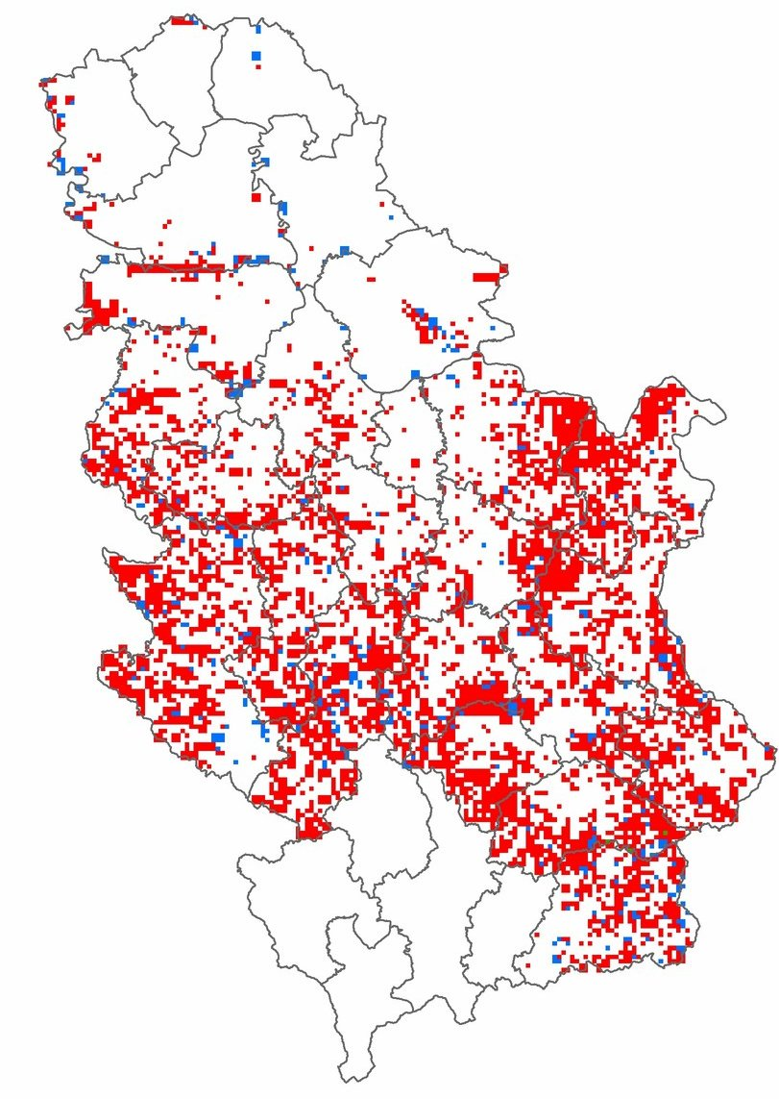
Figure 2 Classification of forests in Serbia according to their naturalness (red - semi-natural, blue - plantations, green - virgin) (NFI, 2009)

Forestry structure
The dominant category of forests in relation to the species composition are European beech (Fagus sylvatica) forests covering 29.4%, followed by Turkey oak (Quercus cerris) forests with share of 15.3%, forest group of acacia (Robinia pseudoacacia), aspen and birch (Betula pendula) with a total of 9.9%, sessile oak forests (Quercus petrea) with 7.7%, forests of Hungarian oak (Quercus frainetto) with 7.1%, hornbeam (Carpinus betulus) with 5.3%, pine forests (Pinus sylvestrs and P. nigra) with 5.6% and spruce forests (Picea abies) with 3.8% (Figure 3).

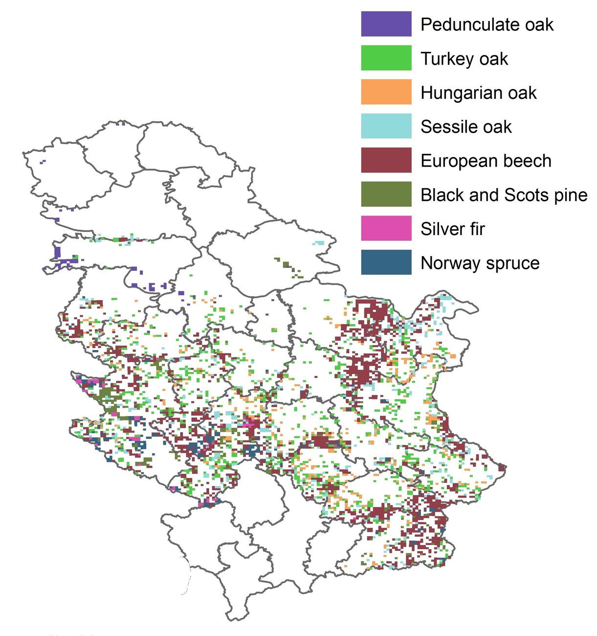
Figure 3 Most abundant tree species in Serbia according (NFI, 2009)

Stands of high origin are represented by 27.5%, coppiced stands with 64.7%, and artificially grown stands with 6.1% and plantations (poplar and willow clones ) with 1.7% (Figure 4).
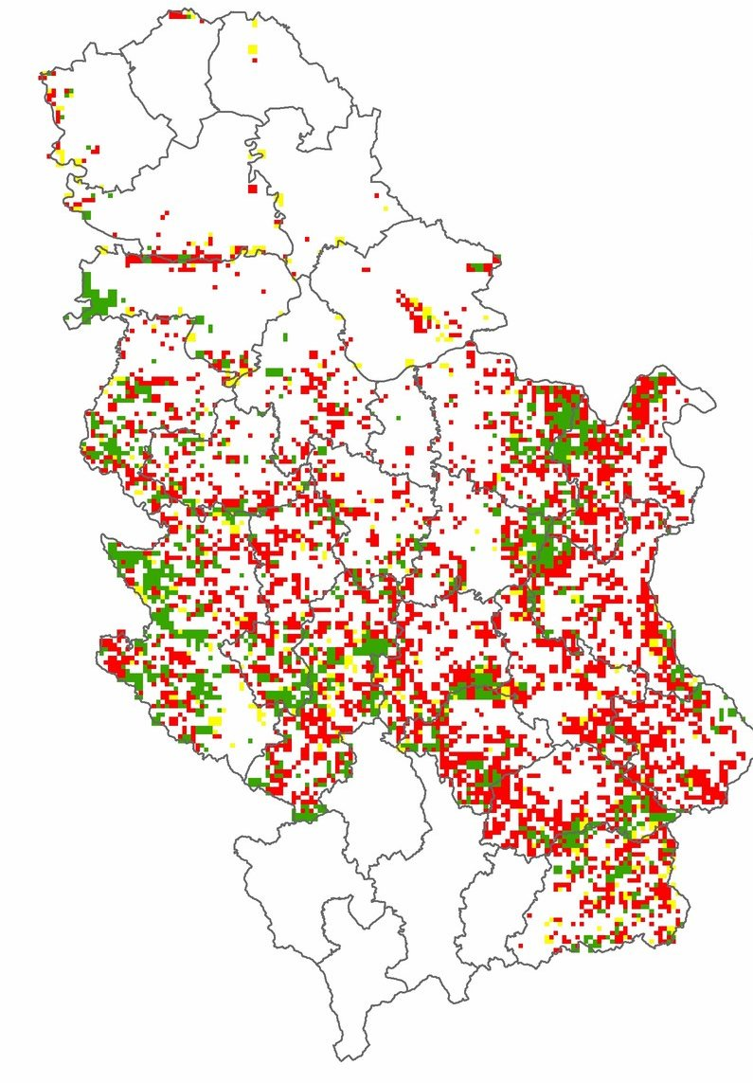

Figure 4 Division of forests in Serbia according to their origin (green - high forests, red - coppiced forest, yellow - artificial stands) (NFI, 2009)

Forest stock volume, increment and logging
The total stock of woody volume is 362.487.418,00 m3, and the annual volume increase is 9.079.773,00 m3. The average value of the stock of timber wood volume is modest 160.9 m3 / ha and volume increment 4.0 m3 / ha. The ownership structure of the forest is characterized by participation of 53.0% (1.194.000 ha) of state-owned forests and 47.0% (1.058.400 ha) of forest owners. In addition to the insufficient level of 29.1%, which lags behind the estimated optimal of 41.4% by 12.3% and the total insufficient value of average wood volume and volume increment of ha of 161.0 m3 and 4.0 m3. The forest also features the following:
1) unfavorable structure by origin and silviculture form: close to 2/3 or 64.7% of the forest surface are edged forests with barely half of the potential inventory (124.4 m3 / ha) and increment (3.1 m3 / ha) that have natural high forests (253.6 m3 / ha; 5.5 m3 / ha); low participation of uneven-aged forests of 8.3% of total surface area, characterized by high volumes and increase (312 m3 / ha and 431 m3 / ha, respectively 6.2 m3 / ha and 9.6 m3 / ha);
2) unfavorable structure after preservation: on 29% of the surface covered, 608,000 hectares and devastated forests (55,200 ha), that is, the forests of an incomplete and interrupted assembly with annual production of wood of only 3.1 and 1.4 m3 / ha;
3) markedly unfavorable age structure of natural high forests with age-group ratio (young: medium: temperate: mature = 38: 20: 13: 29) and offshore forests (51: 33: 7: 9);
4) lack of planned natural regeneration on a significant part of the area of ​​high forests (268,000 ha);
5) unsatisfactory health condition, especially expressed in oak forests, which is particularly intense in the process of chronic drying of forests;
6) unfavorable structure of timber volume: the ratio of the covering of technical and lower class is 33.5: 66.5%;
7) insufficient openness of forest roads at the level of 11.86 m / ha for JP "Srbijašume"), 9.09 m / ha for PE "Vojvodinašume"); in national parks ranging from 14.88 to 18.3 m / ha; in the forests of the owners only 1/3 to 1/2 openness of forests owned by public companies;
8) other potentials of forests and forest habitats (non-wood products and biomass) have not been used to the extent possible

Felling operation

Production of forest sortiments at the annual level in the previous period was 2.5 million m3 of net volume (1.7 million m3 in state owned forests and 0.8 million m3 in forests of owners), with very unfavorable assortment structure of 33.5%: 66.5% of technical and lower class wood.
At the level of the JP "Srbijašume" as a whole, and the "Vojvodinašume" part of the JP, the production of forest assortments (cutting, production and transport) is left to legal entities and entrepreneurs for forestry services, which in most cases are not sufficiently professionally equipped and technically equipped for performing forestry work.
In the Republic of Serbia, there are no uniform norms and norms for the execution of works in forestry, so that the norms for works on cutting, designing and transporting forest assortments from the 1990s are still applied, as well as the temporary norms of works in the area of ​​cultivation and protection of forests.

- Forest Management
- Institutions associated with forestry
Governmental organizations;

Public Forest Enterprise “Srbijašume”

Public Forest Enterprise “Srbijašume” was established in 1992. and managed with the state forests on the area of 892.598 hectares.

Public Forest Enterprise “Vojvodinašume”
Public Forest Enterprise “Vojvodinašume” was established in 2003. and managed with the state forests on the area of 99.000 hectares.
The Public Company for Forest Management “Vojvodinašume” is organised into three organisational levels: Company Directorate, Sections of the Company- forest holdings and the sections of the Company “Vojvodinašume – Lovoturs” Novi Sad – Petrovaradin and „Vojvodinašume-Turist“ Petrovaradin and Work units – forest administrations and other work units.
The Company Directorate performs strategic, development and coordination activities and supervision of work of sections of the Company. Organisational structure of the Directorate consists of sectors.
Forest holdings are established on the level of forestland areas and their organisational structure consists of services.
Forest administrations are basic units for planning and organisation of forest management activities.
Apart from forest holdings such as: “Sremska Mitrovica” Sremska Mitrovica, “Sombor” Sombor, “Novi Sad” Novi Sad and “Banat” Pančevo, the Company also consists of the sections of the Company specialised in hunting and breeding game “Vojvodinašume – Lovoturs” Petrovaradin and „Vojvodinašume-Turist“ Travel Agency is a specialised agency, tour operator.
The Public Company “Vojvodinašume” has over 1,852 employees, out of whom 241 are with university degree, of which 163 are forest engineers; 490 employees with secondary school degree, out of whom 269 are forest technicians and 1,121 employees in direct production (data from 2004).

Forest ownership

Total forest area in Serbia amounts to 2,252,400 ha of which state forests cover 1,194,000 ha or 53.0%, and private forests cover 1,058,400 ha or 47.0%. Compared to previous reference reports (45.2% state forests: 54.8% private forest), the ratio of forest ownership changed in favor of private forests by 1.8%. In general, compared to the reference year 1979, the increase of area under forest is 356,863 ha of state forests and 108,748 ha of private forests. In general, the condition of state forests can be characterized as satisfactory, which is supported by the fact that the average volume in state forests is 185 m3 ∙ha–1, and current volume increment 4.5 m3 ∙ha–1. Increment percentage is 2.4%, which is generally rather high, and proves the stability of stands in Serbian state forests. Private forests are poorer in the quantitative sense, with average volume 133 m3 ∙ha–1 and current volume increment 3.5 m3 ha–1. Increment percentage in private forests is somewhat higher than in state forests and accounts for 2.6%. The reasons are the dominant coppice origin and age structure. It can be concluded that the average volume increased considerably compared to the reference year (1979), when the average volume in state forests was 136 m3 ∙ha–1, current volume increment 3.37 m3 ∙ha–1, and increment percentage 2.5%. In private forests in that period average volume was 91 m3 ha–1, current volume increment 2.32 m3 ∙ha–1, and increment percentage was also 2.5%. As for the annual changes, it can be concluded that the average volume increased in state forests by 2 m3 ∙ha–1 annually, and in private forests by 1.6 m3 ∙ha–1 annually. These facts should be manipulated with care, because of the previous data collection procedure and intensity (till 1979), particularly in private forests, which was based on stand inventory data, and the method of assessment was applied in the unmanaged part of the area in state forests. Private forests were managed and inventoried minimally by the inventory 1947-1949, and the statistical data per years and periods were calculated by balance compared to the mentioned inventory. Forest density, expressed by the number of trees per ha, was considerably higher in private forests and amounted to 1,011 trees∙ha–1 compared to 875 trees∙ha–1 in state forests. The cause of the higher number of trees per ha in private forests is their more unfavourable age structure (younger forests), the dominant coppice origin and, for this reason, the dominant even-aged stand structure.

Forestry policy

After the system change in the 90es of the last century Serbia became „new democracy“ and passed transformation from centrally planned economy towards the system based on market economy. Along with this transformation process the existing sectoral policies were either changed or newly formulated. In the Serbian forest sector most of substantial change, like formulation of new strategic and legislative documents as well as consideration of changes in existing organizations (e.g. public forest enterprises), can be traced back to the period 2000-2010 and internationally-assisted projects (e.g. FAO) as main drivers.
The Forestry Development Strategy of the Republic of Serbia (2006), emerged as an outcome of the project funded by the Finnish Government, executed by the FAO and facilitated by the Directorate of forestry. Two principles, forest sustainability (sustainability of forests and forestry development) and forest multifunctionality are strongly emphasized. The main strategic goal is clearly formulated in terms of “maintaining and improving forest condition and pursuing development of forestry as an integral part of overall economy”. For the realization of this goal, the Government committed itself, among others, to provide enabling regulatory, institutional and economic framework and to launch activities on the formulation of the National Forest Program (NFP) as the action framework for the development of the forest sector. This forest policy framework is not in place yet.
The new Forest Law was enacted in 2010 and its most essential change was that the private forest ownership was put on the equal footing with the state one. The Law differentiates among “državne šume” (state-owned forest) and “šume sopstvenika”, the latter being comprised of forests belonging to “physical persons” (private forest owners) and forests owned by “juristic persons” as companies (“privredna društva”), cooperatives (“zadruge”), citizen associations („udruženja građana“) or church and other religious communities. The term “public forests” (usually referred to forests owned by public organizations such as state and municipal bodies) is not used as such. The Law gives attention to above mentioned owner-ship categories, yet it keeps focus on their “quantitative characteristics”, e.g. it differentiates between “šume sopstvenika” above 100 ha and under that size, whereas qualitative aspects remain unspecified. The single priority seems to be given to the “interests of the forest”, which is by the Law proclaimed as a good of a common interest. There is no explicit reference to the interests of the various forest owners (public/private; large/small, rural/urban, etc.) and forest users.

'Program for forestry' development remains, as a strategic budgetary-financed document, it refers now to the territory of the whole Serbia (previously it was divided between the Republic and the provincial level but this is not the case anymore, because provincial competences in forestry matters are terminated) and the issuing body is not the Parliament but the Government (2015). Action plan remains as an implementation mean, yet the Minis-try is not obliged to provide annual progress reports to the Government (2015), as this was required before.

Investigation and monitoring of forestry resources
National forest inventory is financed from the national budget and shall be conducted every ten years “for the purpose of getting the state of the forests measured and used for strategic sector planning, for other state organs or economy branches, defense or research”. Inventory is a responsibility of the Ministry in charge for forestry, which can transfer this duty via public calls for tenders.

4. Forestry Research and Education
Forestry Research
The existing research capacities in the forestry of the Republic of Serbia are concentrated in the following three institutions: Faculty of Forestry, University of Belgrade (Educational Research), Institute for Lowland Forestry and Environment Novi Sad- University of Novi Sad (Educational Research), and Forestry Institute of Belgrade (research). In these institutions, more than 85 teachers and researchers are employed that cover all significant research and education areas, as well as in all highly developed countries.

The Faculty of Forestry of the University of Belgrade is the oldest and the highest scientific institution of higher education in the fields of Forestry, Technology, management and design of furniture and wood products, Landscape architecture and horticulture and Ecological engineering for soil and water resources protection in Serbia. As a part of permanent education the Faculty organizes knowledge innovations, professional improvement trainings and education of professionals of various specializations.

The Faculty has four departments:
Department of Forestry
Department of Technology, Management and Design of Furniture and Wood Products
Department of Landscape Architecture and Horticulture and
Department of Ecological Engineering for Soil and Water Resources Protection.

The change to Bologna system implies three levels of studies. Each of the levels of studies brings a corresponding number of ECTS credits. The Faculty of Forestry adopted the structure of studies: 4+1+3.

Doctor of Biotechnical Science ( PhD) |  |  | ECTS
3. level | Doctoral studies  ↑ |  | 480
 |  |  | 420
 |  |  | 360
Graduate Forest Engineer (MSc) |  |  | 300
2. level Master's degree study program  studies |  |  | 60
Forest Engineer (4years) ( BSc)
1. level | ↑  Bachelor study program |  | 240
 |  |  | 180
 |  |  | 120
 |  |  | 60

The first level of studies (Bachelor) are undergraduate academic studies. In all study programs of undergraduate academic studies the duration is 4 years, and upon graduation students acquire 240 ECTS credits and the professional title forest engineer in the field studied at their department.
The second level of studies is the master’s degree study program. It lasts for one year and the student obtains 60 ECTS credits. Master’s degree means a certain level of specialization as well as being qualified for research. By defending their Master’s degree thesis students obtain the academic title: graduate forest engineer in the field studied at their department.
The third level of studies- PhD is doctoral studies. They last for three years and the students obtain 180 ECTS credits and the title Doctor of Biotechnical Science.
Besides keeping the values based on national and cultural features that enrich the European academic educational field, the aim of the reform of the scientific and educational work at the Faculty is also the protection of natural heritage, sustainable utilization of natural resources on ecological grounds and generally environmental protection with the application of modern technologies.
The Faculty has two teaching bases for the field training of students with facilities for student and teacher accommodation. More details and photos of these facilities are available at: http://www.sfb.bg.ac.rs/index.php?option=com_content&view=article&id=251&Itemid=65&lang=sr
More information on the official website of the Faculty: www.sfb.rs

University of Novi Sad, Institute of Lowland Forestry and Environment (ILFE), was established in 1958. A total number of researchers, professors, assistants and PhD students are 30. Institute of Lowland Forestry and Environment (ILFE) conducts diverse research and knowledge-transfer activities related to forestry and environmental issues as an independent entity embedded within the second largest Serbian University of Novi Sad. ILFE has its main competences in all aspects of forestry (poplar plantations, short rotation coppice, climate change – impact, adaptation and mitigation, natural forests, monitoring of forest ecosystems, etc.), which is accompanied by agro-forestry, environmental expertise as well as competence in forest and forest-related policy analysis (policies, instruments, actors, evaluations, etc.). The research activities were focused on poplars, willows, beech, oaks, wild cherry, spruce. ILFE has been recognized by the plurality of national forest-related stakeholders for its knowledge-transfer role. ILFE was an FP7-project coordinator (STREPOW) and participated/participates in numerous international (FP7 RoK-FOR, FP7-EXPEER, IPA Oxit, IPA ForestFlow) and national consortia.
Regarding economic and social impacts ILFE’s forest policy researchers examined perceptions and attitudes towards energy wood production and use, conceptual and legal frameworks related to renewable energy as well as state and perspectives of using privately owned forests for energy purposes. Also, consultation processes on forest biomass were successfully organized within the FP7-project RoK-FOR.
On national level, ILFE is involved in two key projects of Ministry of Education and Science of the Republic of Serbia:
III 43002 "Biosensing technology and global system for continuous research and integrated management of ecosystems" (2011-2017).
III 43007 "Research of climate change: monitoring impacts, adaptation and mitigation" (2011-2017).
Ilfe also participated in several European funded COST Actions:
COST action FP0703 Expected Climate change and options for European silviculture (ECHOES); COST Action FP 0903 Climate Change and Forest Mitigation and Adaptation in a Polluted Environment; COST action FP 0905 Biosafety of forest transgenic trees: improving the scientific basis for safe tree development and implementation of EU policy directives (OC2009-1-4625); COST Action FP1401 A global network of nurseries as early warning system against alien tree pests (Global Warning). COST action FP ЕS1203 Enhancing the resilience capacity of SENSitive mountain FORest ecosystems under environmental change (SENSFOR); COST action FP1201 Forest Land Ownership Changes in Europe: Significance for Management And Policy (FACESMAP); COST action FP1403; Non-native tree species for european forests - experiences, risks and opportunities (NNEXT); COST action FP1202; Strengthening conservation: a key issue for adaptation of marginal/peripheral populations of forest trees to climate change in Europe (MaP-FGR); COST action ES1308 ClimMani: Climate Change Manipulation Experiments in Terrestrial Ecosystems: Networking and Outreach; COST Action FP1206 European mixed forests - Integrating Scientific Knowledge in Sustainable Forest Management. (EuMIXFOR); COST Action FP1204 Green Infrastructure approach: linking environmental with social aspects in studying and managing urban forests; COST Action FP1106 Studying Tree Responses to extreme Events: a SynthesiS-(STReESS); FPS COST Action FP1102 Determining Invasiveness And Risk Of Dothistroma (DIAROD); COST action E42 Growing valuable broadleaved tree species; COST action E52 Evaluation of Beech genetic resources for sustainable forestry; COST action E47 European network for vegetation management: Towards environmental sustainability.
ILFE has the Experimental area “Kaćka Šuma“, on the area of 358 ha which is located north-east of Novi Sad, near the village Kać. The Experimental area is an experimental polygon for field research of biological, ecological and production characteristics of lowland woody species (Populus sp., Salix sp., Robinia pseudoacacia, Quercus robur, Fraxinus angustifolia, Fraxinus excelsior, Prunus avium, Sorbus sp.). The Experimental area contains the genetic collections (ex situ) of lowland woody species, as well as the species for honey bee pasture, black locust seed orchard. A part of the Experimental area is used for the production of good-quality planting stock intended for the marke.
ILFE is involved in educational process through participation in PhD program "Forestry" at Faculty of Agriculture and bachelor program which is in the process of establishing at the same Faculty.
More details are available on www.ilfe.org

The Institute of Forestry, founded by the Government of the Republic of Serbia in 1946, have successful practice of basic, applied and development research in the field of forestry and environmental protection and improvement. The Institute income is realized by its participation in research projects funded by the Ministry of Education, Science and Technological Development of Serbia, the Ministry of Agriculture, Environmental Protection and Water Management – Forest Directorate, the Secretariat of Environment of the City of Belgrade, SE “Srbijasume” and others institutions. In addition to research, we offer consulting, engineering and design services. Thanks to its exceptional offer of products and services, the Institute of Forestry is a reliable partner in the pursuit of inventive scientific and technical solutions in the field of forestry and environmental protection.
Institute of Forestry is actively involved in the drafting and adoption of laws, spatial plans, medium-term and long-term programs of the development, protection and improvement of the environment, multidisciplinary projects, studies and many expertise.
Scientific research profile of the Institute of Forestry has been developed as a synthesis of scientific and expert knowledge in the field of forestry and environmental protection. Experimental research work in the field of forestry is carried out on permanent and temporary checkpoints and experimental fields, which are located in all major forest complexes on the territory of Serbia, in the experimental forest nurseries, greenhouses.
Researchers of the Institute of Forestry are leaders and members of many highly rated international and national research project teams. Their projects have been successfully implemented through: establishment of new and improvement of existing forests, reclamation and landscaping of the land degraded by surface mining of coal and other raw materials, afforestation of extremely unfavorable sites, soil erosion control, multifunctional valorization of urban forests, spatial planning, forest policy, introduction of new technologies of seedling production and breeding, forest tending and protection.
Today, cooperation with the leading research institutions in Europe, particularly in the Balkan region, is being further strengthened through our participation in international projects. Researchers of the Institute of Forestry are actively involved as leaders or associates in the many projects which constitute the framework of our cooperation programme.
Personnel Structure: There are 50 employees at the Institute – 25 doctors of science (PhDs), 7 Masters of Science (MSc), 5 bachelors (BSc), 1 lawyer, 1 ecc. and 11 secondary graduates.
Мission: To contribute to global sustainable development and improvement of forests, through research studies in forestry and environmental protection.
Vision: To be a leading forest research organization vital to the future of Serbia.
Aims: To make a significant contribution to: the development of science and technology, implementation of scientific achievements, stimulation of social activities, and promotion of international cooperation.
Resources: Scientific staff; modern, well-equipped offices; computer equipment; accredited laboratory; library, information and documentation center; conference/congress hall; glasshouse, greenhouses and nurseries for experimental crop production; Experimental plot “Lipovica”; Archive of living forest fruit trees “Lipovica”; Sample plot “Pester”; 130 Level I sample plots for monitoring forest vitality, Level II sample plots: Kopaonik, Crni Vrh, Mokra Gora.

List of forestry universities

The Faculty of Forestry, University of Belgrade, is the oldest higher education and scientific institution in the Republic of Serbia in the field of forestry, which educates forestry experts since 1920.
At the Faculty of Forestry - the Department of Forestry is enrolled every year for 120 students, mainly according to requirements, rather than real needs and employment opportunities. This method of enrollment leads to personnel hyperproduction.

The Faculty of Agriculture, University of Novi Sad was established in 1954. At the faculty is enrolled every year for 10 students of forestry on PhD level.

The forestry related majors in each forestry universities

Forestry related majors are:
- Forest management and planning
- Silviculture
- Forest protection
- Forest genetics
- Forest physiology
- Soil sciences
- Forest plantations
- High-growing species

Number of forest-related students and the international students
The number of forest related students are more than 180 each year.
5. Forest economics

Forestry contribution to GDP
The number of workers in forestry institutions engaged in forestry is 4,995.These are institutions that are engaged in growing and silviculture, logging, scientific and educated in forestry operations and other activities related to forestry. Wood processing and furniture production in late 2014 consisted of 2,182 companies employing 22,965 workers. More than 90% of companies are privately owned and are mostly located in the central parts of Serbia. Most of these companies are engaged in processing of wood (1,504), primarily the production of sawn timber, joinery and other wood products. Other companies are engaged in manufacturing office furniture, kitchen and other furniture (678). This number of companies is necessary to add approximately 1,600 active entrepreneurs, which largely operate in a gray
area, so the total number of active business entities in the wood industry in Serbia is much higher. In addition to wood processing, it should be noted that hunting and hunting tourism have a symbolic importance in the development of the forestry sector. Hunting services employ 90 people in Serbia. The share in GDP in Serbia is 1.4%, while the forestry and timber industry, its contribution to total exports accounted for 5.7%, with a steady positive trend of growth in recent years. The share of forestry and logging in GDP, without the participation of the processing timber is 0.3%.

Table: Enterprises and number of employees
 | Wood processing |  | Furniture
 | Number of firms | Number of employees | Number of firms | Number of emloyees
Micro | 1.296 | 3.350 | 524 | 1.620
Small | 179 | 3.621 | 106 | 2.114
Medium | 28 | 2.548 | 43 | 4.095
Large | 1 | 582 | 5 | 5.035
Total | 1.504 | 10.101 | 678 | 12.864

Table: Representation of company size as a percentage of the Republic of Serbia

 | Number of companies wood industry | Percentage of representation %
Micro | 1.820 | 83,40%
Small | 285 | 13%
Medioum | 71 | 3,30%
Large | 6 | 0,30%
Total | 2.182 | 100%

The share of medium and large companies is very small in the wood processing and is only 3.6%. This structure of companies is relatively unfavorable from the point of export competitiveness and their position in major export markets. Analysis of data from the Action Plan support the timber industry of the number of companies in relation to their activity and spatial distribution shows that the total number of companies engaged in primary wood processing extremely large and that there is a significant mismatch between their capacities and schedules with production potential of forests. The largest number of registered firms located in regions with the lowest forest cover. Comparing the total annual growth of the number of enterprises for the production of sawn timber, it can be concluded that in some regions, especially Backa and Belgrade, the installed capacity of which is a high percentage of raw materials necessary to ensure the shipment on the side with a distance over 300 km. In the area of ​​Belgrade, where the participation of forests is only 2.3% of the total forest area in Serbia, employ 37.1% of workers. In other regions such as Bor, Zajecar and Pirot number of companies involved in processing of roundwood is extremely small. In the area of ​​these three districts recorded an annual growth of forests in the amount of 16% of the total increase in Serbia. On the other hand, the number of registered companies in the field of wood processing was only 2.5% compared to the total number of all companies in Serbia. The low level of use of local raw materials and a small number of companies for wood processing in certain areas directly leads to a reduction in the number of employees, which further leads to depopulation. Therefore, further development of the manufacturing industry, especially in wooded areas has a very important role in increasing the employment rate, increasing the welfare of society, and to a certain extent, the increase in overall GDP.
Forest products import and export trade
In addition to agriculture and food industry, wood industry is the second most important sector in the country, which has a constant trade surplus. Regarding the structure of exports, one half of export products belonging to the furniture industry, and the other half of other products of wood. Considering the free trade agreement has increased the export of furniture to Russia by 50% in 2014 when compared to 2013. During the past decade, the timber industry has been one of the most attractive sectors for foreign investors. Tarkett French, Italian Ditre Gruppo and Fantoni, Austrian Kronospan and many others have built their factories in Serbia in order to supply not only domestic regional markets, but also of the EU market and the market of the Russian Federation. Sawmilling traditions in Serbia dates from the early 19th century. Today, Serbia is the second largest producer of sawn timber beech and poplar wood and the third largest producer of sawn hardwood in the Balkans. Sawn timber, except furniture is the most important forest product of the wood processing industry in Serbia. Sawmill account for 63% of total wood processing enterprises in Serbia. Annual production of lumber sawmills exceeds 300,000m³, 80% of which is beech and poplar wood. Chipboard is a wood product with the highest demand in Serbia. Although the Austrian company Kronospan invested in the factory plate in Lapovo town in 2009, and the Italian company Fantoni privatized Serbian company "Spik Ivanjica Chipboard”, demand for plates is still very high. Increasing domestic production was insufficient to meet the needs of the market, so imports of particle board is 8,000,000 $ per month. When it comes to the production of veneer, peeled veneer makes up about 90% of the total production of veneer and poplar peeled veneer is a leading product, while beech veneer second quantity of production. In Serbia, products and oak, ash and walnut veneer. The production of hardboard panels varied significantly in the past. After the drastic fall of 61% in 1999, production began to increase after 2000. Hardboard is manufactured exclusively at the factory "Simpo Kuršumlija" with a capacity of over 40.000 m3 per year. In addition to use in the domestic market, exported to Greece and Turkey, although the import of this product is very large, mainly from Germany and Hungary. In recent years there has been a significant increase in the production of panels of solid wood. The products are mainly made of beech and poplar. These products are used for stairs, tabletops and other furniture parts. Expansion of production companies that were engaged in sawmilling, especially in Central Serbia, created a product that has significantly increased exports slab of wood. The main export markets are Germany and Italy. Production of wood joinery has a long tradition in Serbia. A large number of companies manufacturing high quality windows and doors, a significant quantity directly exported to the Russian Federation and the EU. Manufacture of doors and windows mainly of oak and beech, however, and spruce and fir are common raw materials. The latest product in wood industry is a pallet. Pellet market in Serbia has been around since 2006, but intensive pellet production began in 2008. In Serbia, the pellets produced from beech and poplar wood with small stakes spruce. Today a large part of pellet production is exported, the main export markets are Italy, Germany and Greece. Wood accessories is one of the most important for the wood industry. Exports of wooden hangers and various other articles of wood is increasing, a major export market besides Italy and Germany as Finland, the Netherlands and Switzerland. Furniture produced in Serbia can be classified into three categories: furniture of solid wood, panel furniture and upholstery. About 30% of the produced furniture is furniture from the massif.
This is the most expensive furniture produced from domestic raw materials, and it is mainly exported. Factories that produce furniture in Serbia are equipped with modern machines and follow world trends, both in preparation and in the surface treatment, and the products are competitive on the European market.
Table: Import and export of wood products (US$)
Wood products | Export | Import | Total
Sawn wood | 70.287.067 | 47.596.879 | 22.690.188
Impregnaton of wood | 386.387 | 955.015 | -568.628
Boards of wood | 54.839.457 | 100.195.619 | -45.356.162
Construction elements | 59.272.137 | 13.491.463 | 45.780.674
Packaging | 19.767.846 | 10.291.898 | 9.475.948
Other articles of wood | 26.889.749 | 4.608.295 | 22.281.454
Furniture | 167.659.065 | 44.966.160 | 122.692.905
Total wood industry | 399.101.708 | 222.105.329 | 176.996.379
In the current use of natural resources as well as forestry industries, the dominant role is the use of wood, while the use of other forest products partially neglected. Such an attitude is not good, especially in the current business conditions when circumstances require the use of all available resources with which forestry as a branch of economy and society in general have. Modern food, pharmaceutical and cosmetic industry is increasing the use of indigenous medicinal plants, fruits, mushrooms and other forest products. In our economy, non-timber products are gaining in importance expansion of healthy food and a healthy diet. However, considering the official statistical analyzes, there is no concrete data on how much traffic and realize how many people live by this type of economy. Production and trade of non-timber products still represented more at the local level and it is mainly concerned with nature lovers. Neglecting the development of this type of production can be a strategic error of the economy as a whole, especially if it is known that the Republic of Serbia is one of the most suitable places to launch organic production. Organic farming can be one of the most important advantages of the domestic economy, and with this kind of production and positioning in the global market should lead to the development of production and trade of non-timber products.

Forestry – related industrial chain
The chain of production and supply is gaining importance in industrial production, the sale and the successful creation of surplus value. Efficiently locate and use resources effectively set logistics and the development of primary and secondary processing industry is one of the priorities of all sectors within the economy that operates in global economic conditions, strong competition, which is now reflected in each business field. Forestry is in the field was the economy, which has to be based on the concept of sustainable development, which is now accepted in all developed economies of the world. To make the concept of sustainable development to be successful, it is necessary to carefully, based on internal resources, establish an efficient supply chain, production and forestry services. Forestry is of great importance for every economy.
The modern industrial chain in forestry is based on raising forest plantations, maintenance, development of hunting tourism, gathering and processing of non-timber products, development of resorts and parks for sports recreation, felling of forest trees, transport, primary production, processing, exports, production and secondary energy production and secondary processing of primary products. This is a complete production chain has been successfully installed in many developed economies, where he carefully takes into account the successful use of each production, manufacturing and service potential, provided it is not detrimental to the environment and sustainable development without threaten future generations. This kind of use of forest resources is the establishment of architecture in economic terms, which aims to facilitate the development of advanced systems planning, analysis, production and marketing of forest products. When it comes to forestry and its organization in Serbia, it should be noted that under the influence of the European Union is slowly taking over the development of concepts of European countries. The chain of production and supply in Serbia has its cracks, or the work of foresters and entrepreneurs with extensive experience in forestry production tries to establish a functional chain of production in forestry, in local and regional contexts. Serbia is slowly rebuilding its forest resources. Raising the nursery and seedling development of quality materials, the initial item in restoring forest resources and the establishment of successful forestry. In the production of nursery plants, improvement of forest species and care of young forests play a major role forestry institutes, among which the Institute of Lowland Forestry and Environment in Novi Sad. Important preconditions are the development of forestry and road infrastructure to facilitate transport and reduce the cost of inbound and outbound logistics at cutting wood. The thing is necessary to pay more attention to the domestic front, the development and establishment of a culture of collecting non-timber products which can be a significant segment of the concept of organic food production, which should be based on the local economy and develop a strategic advantage over the competition production chain. Transport is one of the most important items accompanying forestry production. It is necessary to carefully establish and logistics companies in forest and timber processors with the industry to a quick and inexpensive way to provide input - output road and river transport raw materials and products. When it comes to the domestic economy, it is necessary to spend a lot of effort and energy with the help of domestic and foreign capital to develop the primary and secondary sectors of production and properly utilize local and regional resources in forestry. Increasing industrialization in forestry, will increase
employment and overall welfare of the society, but at the same time must be taken to move the industrialization in rural areas, and thus enable the balanced development of the country. It should not be omitted, and the production of energy and reduce dependence on imported energy, using primary forestry product, but also uses secondary product from wood industry. In addition, should the maximum impact on the development of forest, mountain and spa centers that will develop the services sector and enable the reduction of unemployment in those regions. This will allow people to enjoy the natural beauty of the forest and use resources in order to recreate, enjoy healthy lifestyles and increased overall health of the nation. We can conclude that it has successfully created a chain of forestry production is necessary for the normal functioning of a society and economy. It is necessary that the chain is strictly controlled so as not to threaten the concept of sustainable development and threaten the survival of future generations in the country and the World.

