**ROMANIA FORESTRY REPORT**

**1. Brief Country Profile**

Romania is a sovereign state located in Southeastern Europe. It borders the Black Sea, Bulgaria, Ukraine, Hungary, Serbia, and Republic of Moldova and lies between latitudes 43° and 49° N, and longitudes 20° and 30° E. It has an area of 238 397 square kilometers (92 046 sq mi) and a temperate-continental climate. With almost 20 million inhabitants, the country is the seventh most populous member state of the European Union. Its capital and largest city, Bucharest, is the sixth-largest city in the EU, with 1 883 425 inhabitants as of 2011.

The terrain is distributed roughly equally between mountains (Southern Carpathians Mountains), hills, plains, rivers (Danube River), sea (Black Sea), Danube Delta Biosphere Reserve. The River Danube, Europe's second-longest river, rises in Germany and flows in a general southeast direction for 2 857 km (1775 mi), coursing through ten countries before emptying into Romania's Danube Delta. The Carpathian Mountains, which cross Romania from the north to the southwest, include Moldoveanu, at 2 544 m (8 346 ft).

1. **Forestry and Forest**

The forest area occurs about 7 046 056 ha[1], with 6 900 9621 ha forest coverage. From the forest coverage, an area of 6 555 000[2] ha is included in the National Forestry Fund and it is under the national silvicultural regulations. Between 2011 and 2015 the forest fund coverage has increased (Figure 1).



**2015**

Figure 1. Forest fund coverage change between 2011 and 20152

Regarding the area of each forest classification and its change Basis of classification such as the primary forest, plantation, the Romanian forest are mainly natural regenerated.

In terms of functionality, the forests included in the national forest fund have the following structure (Tab. 1):

Table 1. The distribution of forests by functional groups

|  |  |  |
| --- | --- | --- |
| **Functional Group I** | | |
| It includes forests with special functions of water protection, soil, climate and objectives of national interest, recreation forests, protection forests of the genofond and ecofond, as well as forests in protected natural areas of national interest and occupies 53.3% of the surface of the national forestry fund | Land and soil protection | 43% |
| Water protection  Protection against hazards | 31%  5% |
|  |  |
| Forests with recreational functions | 11% |
| Forests established as protected areas of scientific interest | 10% |

**Functional Group II**

It includes forests designed to fulfill simultaneously the production function (priority) and one or more protection functions and occupies 46.7% of the area of the national forest fund.

With regard to state forests, 60% are classified in functional group I (with special protection functions) and 40% in functional group II (with production and protection functions) (Figure 2).





Figure 2. Structure of forests ownership of the state by functional groups

The basic situation of the tree species composition such as the area and percentage for the main tree species.

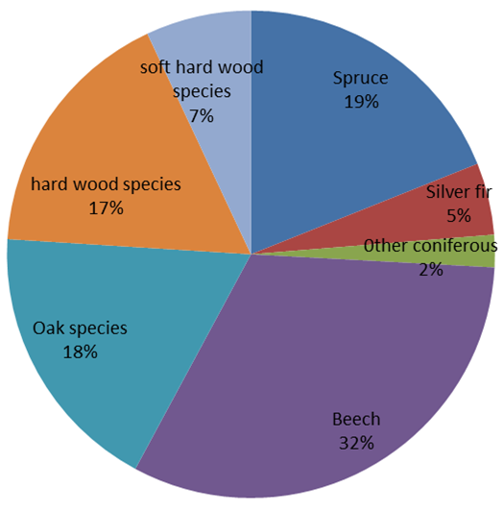The main group tree species in the Romanian forest are coniferous (Spruce, Silver fir and others coniferous species) (26%), Beech (32%), Oak species (18%) hard wood broadleaves (17%) and soft wood broadleaves (7%) (Figure 3).

Figure 3. Forest structure by species and large group of species

The forest stock volume is about 2 221 593 thousand m3 (fig. 3),the annual average increment is about 5.6 m3.y-1.ha-1. Concerning the wood logging, the annually rate is about 18 133 thousand m3. The total volume of timber felled in recent 10 years (Tab. 2).

Table 2. Timber felled (thousand m3) in Romania the recent 10 years

|  |  |  |  |  |
| --- | --- | --- | --- | --- |
| **Year** | **From regeneration cuttings** | **From thinning** | **From Hygiene**  **works** | **Total** |
| *2006* | - | - | - | 15684 |
| *2007* | 13250 | 2964 | 1024 | 17238 |
| *2008* | 11852 | 3043 | 1810 | 16705 |
| *2009* | 11215 | 3375 | 1930 | 16520 |
| *2010* | 12070 | 2933 | 1989 | 16992 |
| *2011* | 13152 | 3584 | 1969 | 18705 |
| *2012* | 13082 | 4071 | 1928 | 19081 |
| *2013* | 12803 | 4162 | 2317 | 19282 |
| *2014* | 11928 | 3785 | 1928 | 17889 |
| *2015* | 12045 | 3889 | 2199 | 18133 |

1. **Forest Management**

For the forestry state area (66.0% of the total forest area), forest management or services are provided by the Romsilva National Forest Administration, while for the others forestry area (34.0%), forest management or services are provided by forest regimes districts.

By the end of 2015 there were 468 forest districts, of which 322 were under the structures of the Romsilva National Forest Administration, 146 forest regime districts, 3 forest districts under the structure of "Marin Drăcea" National Forest Research and Development Institute and 1 forest district under the Autonomous Administration - State Protocol Patrimony Administration.

In Romania, the main governmental institutions associated with forestry are Ministry of Waters and Forests, National Forest Administration - Romsilva, National Institute for Research and Development in Forestry “*Marin Drăcea*”, Regional Forest Guards, National Environment Guard, National Environmental Agency.

The National Forest Administration - Romsilva operates under the authority of the Ministry of Waters and Forests. The main purpose is to ensure sustainable and unitary management, in accordance with the provisions of the forestry and forestry rules, of the public property fund of the state in order to increase the contribution of the forests to the improvement of the environment conditions and to ensure the national economy with wood, forest products and specific forest services. It also deals with the coordination and implementation of the national horse breeding program, national and international promotion of valuable horses from the herds of the Romsilva National Forest Administration through the organization of sports competitions, fairs and exhibitions. At the same time, through the 22 parish administrations, units with legal personality, RNP-Romsilva administers 23 national and natural parks in which the state-owned forestry fund has a significant share, ensuring biodiversity conservation in these protected areas.

The non-governmental organizations are: Romanian Forest Association (ASFOR), Association of the Private Forest Administration (AAPP), Owners Association of the Private Forests, The Silvic Forest Society, Proforest Association, Professional Association of Forest Service Providers in Romania, Federation for the Protection of Forests.

The number of employees in forestry is about 41 300 employees[3]. With regard to the dynamic variation in the number of employees in the forestry sector, there is a decrease in the number of employees from 1990 to 2010 (Tab. 3).

Table 3. Employment in forestry during the period 1990-2010

|  |  |  |  |  |
| --- | --- | --- | --- | --- |
| **Category** | **Employment** | | | |
| **1990** | **2000** | **2005** | **2010** |
| Employment in forestry | 78 500 | 70 500 | 59 800 | 41300 |

The area and percentage of the forest ownership including private and state owned and public forest are presented in Figure 4.

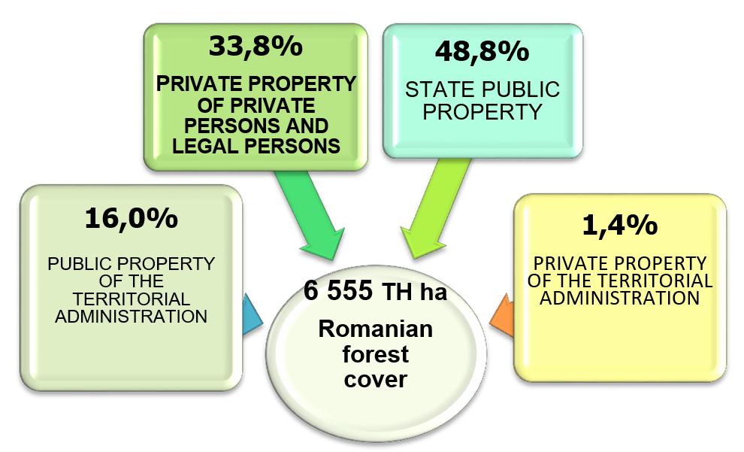

Figure 4. National forest fund structure by type of ownership

Over the last decade, with the change of legislation, the type of forest ownership has been constantly changing (Tab. 4).

Table 4. The dynamics of the change of type of ownership in the forest fund

|  |  |  |  |  |  |
| --- | --- | --- | --- | --- | --- |
| Year | Surface of the national forest fund | | | | |
| TOTAL  (th. ha)  ( %) | Property type | | | |
| Public of the state  (%) | Public of the territorial administration  (%) | Private of the territorial administration  (%) | Private of private persons and legal persons  (%) |
| 2005 | 100  (6391) | 66,3 | 13,3 | - | 20,4 |
| 2010 | 100  (6515) | 51,3 | 15,7 | 1,1 | 31,9 |
| 2015 | 100 (6555) | 48,8 | 16,0 | 1,4 | 33,8 |

The main Forest - related policies and laws are:

a) Law no. 46/2008 – The Forest Code is the main law governing the forestry regime in Romania, thus creating the legal, technical and economic framework necessary to ensure a sustainable management of the forests of the country. Elaborated in 2008 (latest version), the Forest Code has undergone numerous modifications aimed at improving the forestry regime (last modification in July 2017). It divides the forest area into: public property of the state and territorial administrative units and also private property of communities and of natural and legal persons (individuals, associations, schools, churches, etc.).

b) *Law no. 134/2017 regarding the establishment and sanctioning of forest contraventions -* this law is aimed at completing the forest code, providing the contraventions to the forest management and administration, integrity of the forest fund, forest protection, forest regeneration and valuation of wood/non-wood products, as well as procedures for findings and sanctions.

c) *Law no. 100/2010 on the afforestation of degraded lands.* The normative act details paragraph 53 of the Annex to the Forestry Code and refers to degraded land irrespective of the form of ownership, for its improvement by land-use works in order to protect the soil, restore hydrological equilibrium and improve environmental conditions.

d) *Law no. 289/2002 regarding the forest shelter belts.* This low refers to the plantations with forest vegetation, with different lengths and relatively narrow sides, located in such order as to protect different objectives (e.g. cities, roads, agricultural crops) against the effects of some harmful factors like: soil erosion, snow blizzards, floods or pollution.

e) *Law no. 56/2010 regarding the accessibility of the national forestry fund.*  Accessibility is an important factor in the sustainable management of the national forests, and can be achieved either by road construction works or by investments on the existing roads, in order to maintain their functionality.

f) *Government Emergency Ordinance no. 59/2000 on the status of forestry personnel*. This governmental act was approved with amendments and completions *by Law no. 427/2001*. According to the law, forestry personnel are those who have forestry training attested by the act of graduation of a recognized education institution in Romania and who actually practice forestry profession in the field of forestry.

g) *Emergency Ordinance of the Government no. 85/2006 on the establishment of ways of assessing the damages caused to forest vegetation in and out of forests.* This governmental act was approved with amendments and completions by *Law no. 84/2007*. Under this law, damage means the modification of appearance, physical integrity and / or physiological characteristics of the tree / trees naturally regenerated or planted, resulting from different forms of degradation whether or not followed by their appropriation, under unlawful conditions.

h) *Governmental Decision no. 470/2014* for the approval of the Norms on the provenance, movement and trade of wood materials, the regime of wood storage facilities and round wood processing plants, laying down the obligations of operators who place timber and timber products on the market.

i) *Emergency Ordinance of the Government no. 32/2015* for setting up Forest Guards. Regulation aims at guarding the national forest fund against illegal occupation, illegal cutting of trees, theft, degradation of forests or any kind of land located in the forest, grazing, and against other damaging factors.

At the level of assumed policies, we find:

j) Governmental Decision no. 617/2016 for the approval of the Regulation for the utilization of the wood from the public property forest fund.

***Investigation and monitoring of forestry resources***

Since 1990 Romania, is a member country of UN ECE ICP- Forests Program and forest monitoring activity was carried out at a large scale; the forest condition surveys were based on a permanent European grid sys­tem plots (level I) (16x16 km) and in 1992 on intensive plots was placed in representative forest ecosystems within a nonsystematic network (level II -12 permanent plots). Additionally, in Romania, long term socio-ecological research was developed in two LTSER sites (Retezat and Bucegi - Piatra Craiului).

During the 2010 - 2015 periods, health status of the Romanian forests is slightly affected (percentage of tress damaged was situated between 14 and 17). Generally, conifers are slightly more affected than broadleaves except 2010 and 2015 (Figure 5).

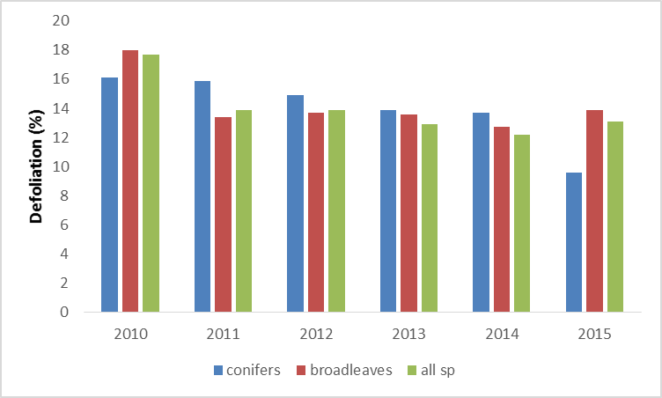

Figure 5. The dynamics of the health (Def**≤**25) and damaged (Def>25) trees percentage during the 2010-2015 period (level I plots – 16x16 km)

The National Forest Inventory (NFI)[4] is the main instrument to assess country’s forest resources, and it has to answer to the ever-increasing needs of information on forest. The main task of NFI consists of collecting, storing, managing an analyzing data and information regarding forest resources, as well as of publishing the study outcomes.

In addition, NFI conducts studies and prognoses on the evolution of forest resources and forestry sector development, aiming at contributing to elaborating national forest policy and cross-sectorial cooperation.

NFI is the main data provider for reporting on indicators for sustainable forest management, according to the Romanian commitments within the framework of the Ministerial Conference on the Protection of Forest in Europe (MCPFE). It also provides essential data on forest resources assessment regularly reporting to FAO, UN-Framework Convention on Climate Change/Kyoto Protocol (UNFCCC/KP) and to Convention on Biological Diversity (CBD).

The activity of NFI is very complex, consisting of data collecting from the field, GIS analyses and digital photogrammetry, laboratory analyses and processing, and statistical analyses of large amount of data.

**4. Forestry Research and Education**

The National Institute for Research and Development in Forestry “*Marin Drăcea*” is the main organization which provide research activities. Its mission is to scientifically base the management and development of the forest sector through the production and dissemination of scientific and technical information, the provision of specialized consultancy, the creation, transfer and implementation of new or upgraded technologies, the development of innovative products to contribute to increasing the competitiveness of the forest sector and the welfare of society.

Also, the Academy of Agricultural and Forestry Sciences (ASAS), research centers from universities, non-governmental organizations and private companies are involved in research activities.

Concerning the forest related institutions, Ministry of Waters and Forests, National Forest Administration - Romsilva, Academy of Agricultural and Forestry Sciences (ASAS), National Institute for Research and Development in Forestry “Marin Drăcea”, Regional Forest Guards, National Environment Guard, National Environmental Agency are the main ones.

The forestry universities in Romania are:

* [“Transilvania](https://www.google.ro/search?client=firefox-b&dcr=0&output=search&tbm=lcl&q=Universitatea+Transilvania&ludocid=9473387006299273487&sa=X&ved=0ahUKEwiT44mSwqbWAhXLChoKHacUAu8Q8G0IDygAMAM)” University of Brasov- Faculty of Silviculture and Forest Engineering
* University of Agricultural Sciences and Veterinary Medicine of Bucharest- Faculty of Agriculture - Silviculture Section
* “Ștefan cel Mare” University - Faculty of Silviculture
* **University of Agricultural Sciences and Veterinary Medicine of Cluj-Napoca – Faculty of Silviculture**
* **University of Agricultural Sciences and Veterinary Medicine of Banat from Timișoara –** Faculty of Horticulture and Silviculture
* **University of** Craiova – Faculty of Horticulture - Silviculture Section
* University of Oradea, Faculty of Environmental Protection, Department of Forestry and Forest Engineering

The forestry related majors in the forestry universities are: Silviculture, Silviculture and Forest engineering, Remote Sensing in Forestry, Forest Wildlife, Environmental Protection, Forest Cadastre.

Within the 6 university centers, there are currently a number of 2810 students in the forestry faculties.

**5. Forest economics**

The Gross added value of forestry (at basic price) is 2 794.5 million[5] Lei, the country’s GDP and the share of forestry’s contribution is 0.4%[6] (forestry and logging).

The diversity of forest products and units of measurement make it impossible to express them volumetrically, so that the information on foreign trade will be presented in units of value:

* For the wood forest products for the year 2015, the import value is 524 549 Mil Euro and the export value is 1 808 576Mil Euro.
* For the wood forest products for the year 2016, the import value is 629 867 Mil and the export value is 1 642 837Mil Euro.

The harmonization of economic requirements with the imperatives of increasing the role of forests in improving environmental and living conditions, is a high priority of the Romanian sustainable forest management. The area of forests for social and cultural functions is increasing, especially for designation of forests for recreation, tourism, landscape, education, conservation of cultural and spiritual heritage.

1. National Forest Inventory (NFI), 2012
2. National Institute of Statistics (NIS), 2016
3. Collaborative Forest Resources Questionnaire (CFRQ), 2005
4. H00ttp://roifn.ro
5. Global Forestry Resources Assessment 2015 (FRA 2015)
6. http://ec.europa.eu/eurostat/statistics